****Tarlac State University

**COLLEGE OF COMPUTER STUDIES**

Case Study

in

Integrative Programming Technology 2

Submitted By:

**Caisip, Niño Jesus M.**

**Dizon, Jericho E.**

**Lampano, Angelica S.**

**Zapanta, Jhazz B.**

Submitted To:

**Pineda, Kwinno L.**

Date: [Deadline October 29, 2021]

Table of Contents

A. Definition 3

B. Case Analysis (Git and GitHub Workflow) 4

B.1 Documentation 4

B.2 Documentation 29

C. Case Study Webpages 46

D. References 50

References 50

# Definition

The Lab Quiz#2 you did (Static Website) upload the documentation and files in your GitHub repository and add a minimum of 3 more webpages to add in your repository during the development use Git and GitHub and create a documentation of all.

**Add 3 more pages:  
For the development of the 3 Webpages using (Git and GitHub) Issues, Pull Request, Milestone, Branching**

**Quiz # 2:**

**5 Web Pages Upload to GitHub Using Git**

**Requirements:**

* Each member in your group will need to upload **a webpage** from your Quiz#2 to your GitHub repository.
* Create a **Pull Request** for each member in GitHub with comments.
* Create an **Issue** for each member in GitHub.
* Create a **Milestone** for the group in GitHub.
* Create a branch for each member and merge it with your master in GitHub.

**Define and describe how you use of each command with screenshot in your case study.**

* Git clone
* Git Pull
* Git Push
* Git Fetch
* Git Merge
* Issue
* Pull Request
* Milestone
* Branch

**Note: List the contributions of your group members**

# Case Analysis (Git and GitHub Workflow)

## Documentation

Create a narrative documentation, take screenshots to tell and proof your case study. List the things you have done and how you did to the case study, the commands you have use with screenshots. Add gitlog screenshot as reference of history of your commit in your documentation.

* Uploading 5 webpages from previous Lab Quiz 2 to GitHub using Git.
* Using git clone the main branch cloned his remote repository to the local repository [1].

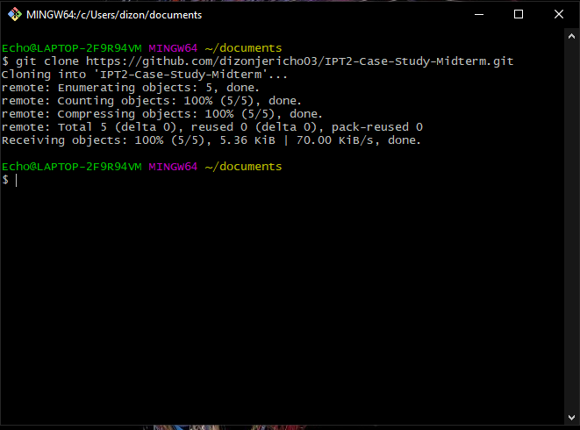

* Using git fetch it downloads the changes from the remote to your local repository.
  + Created a branch in the local repository using git checkout -b.
  + Using git pull it downloads the changes from the remote and merges them into your current branch and local repository.

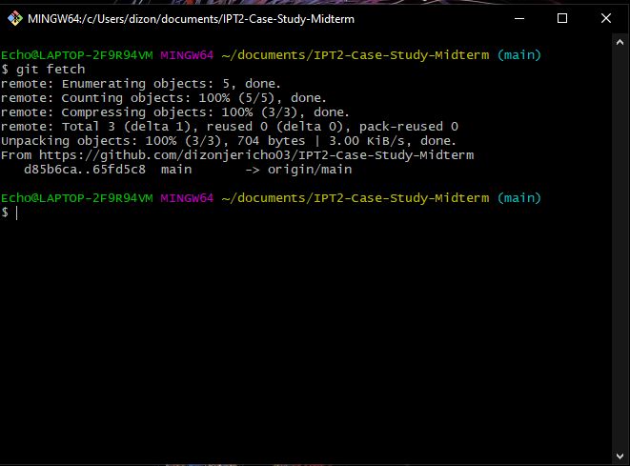

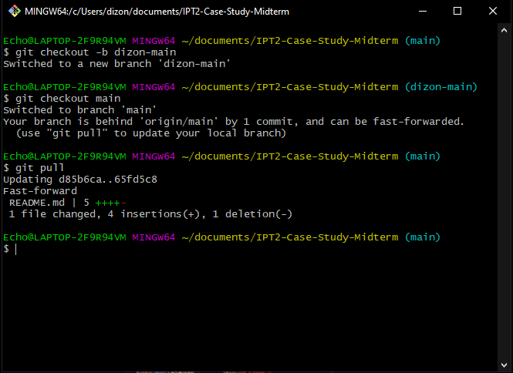

* Added the files from the 5 webpages and used git add and git commit -m.

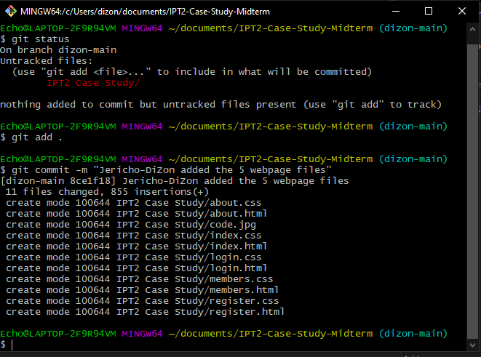

* Merged the main branch with another branch using the git merge –no-ff dizon-main -m “message” command.

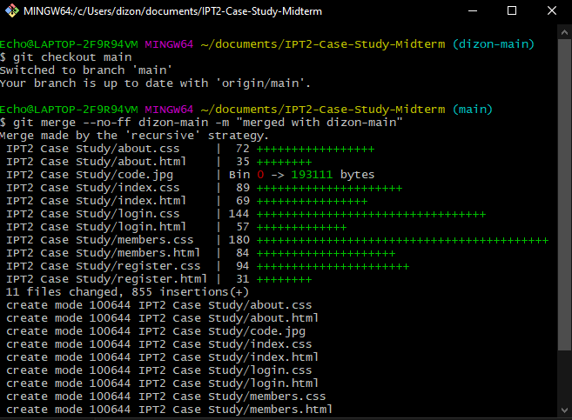

* Using git log we will see the commits of the other branches.

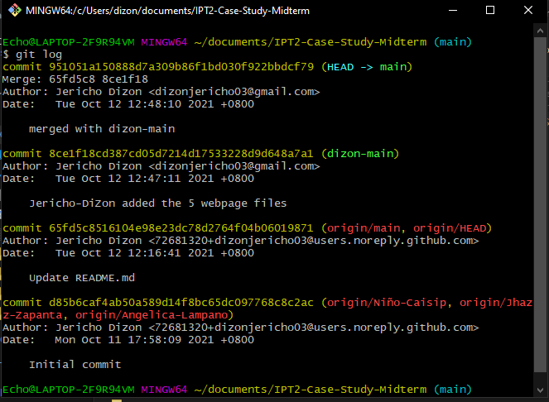

* Using git push origin HEAD:main, I pushed the added files from my local repository to the remote repository in GitHub.

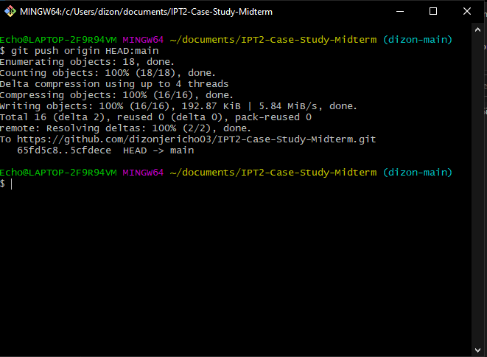

* Create a **Pull Request** for each member in GitHub with comments.
* **Angelica-Lampano** **Pull Request** and **Create Pull Request** in GitHub.

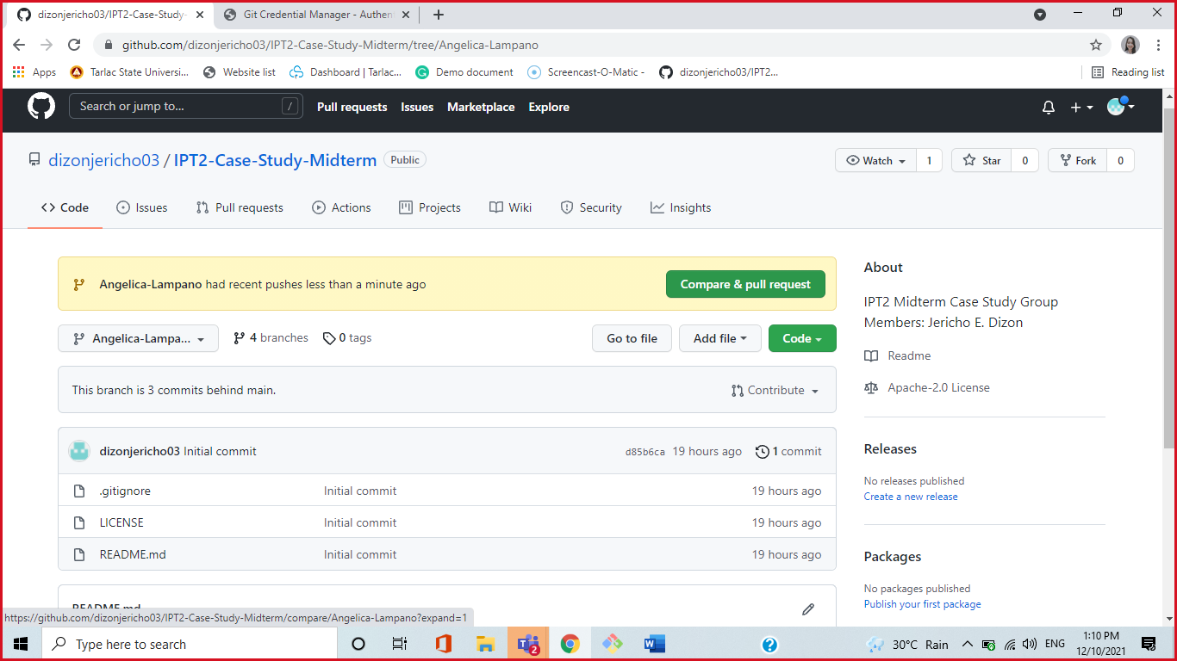

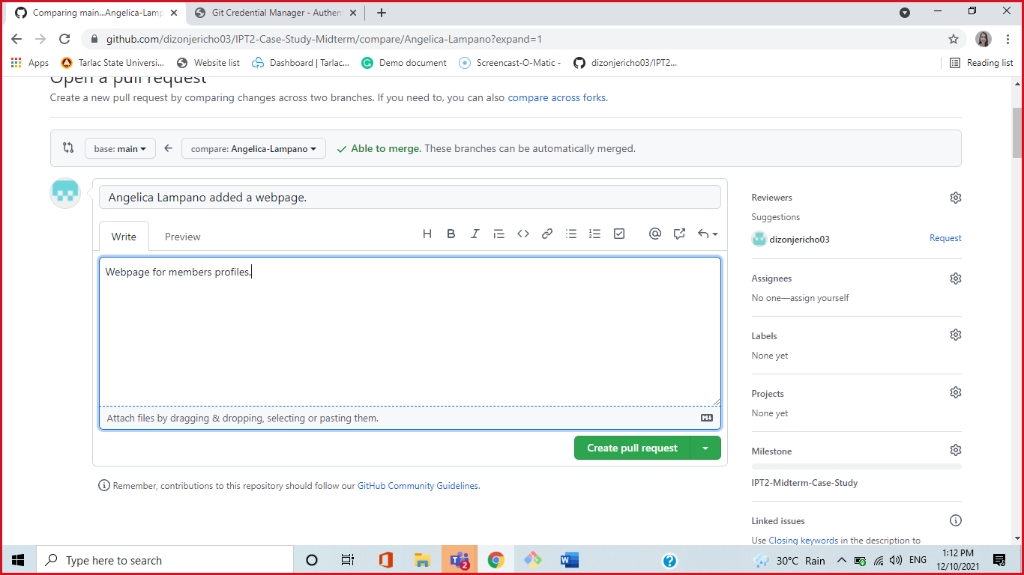

* **Angelica-Lampano Merge Pull Request.**
* Comments and Successful Merge Pull Request.

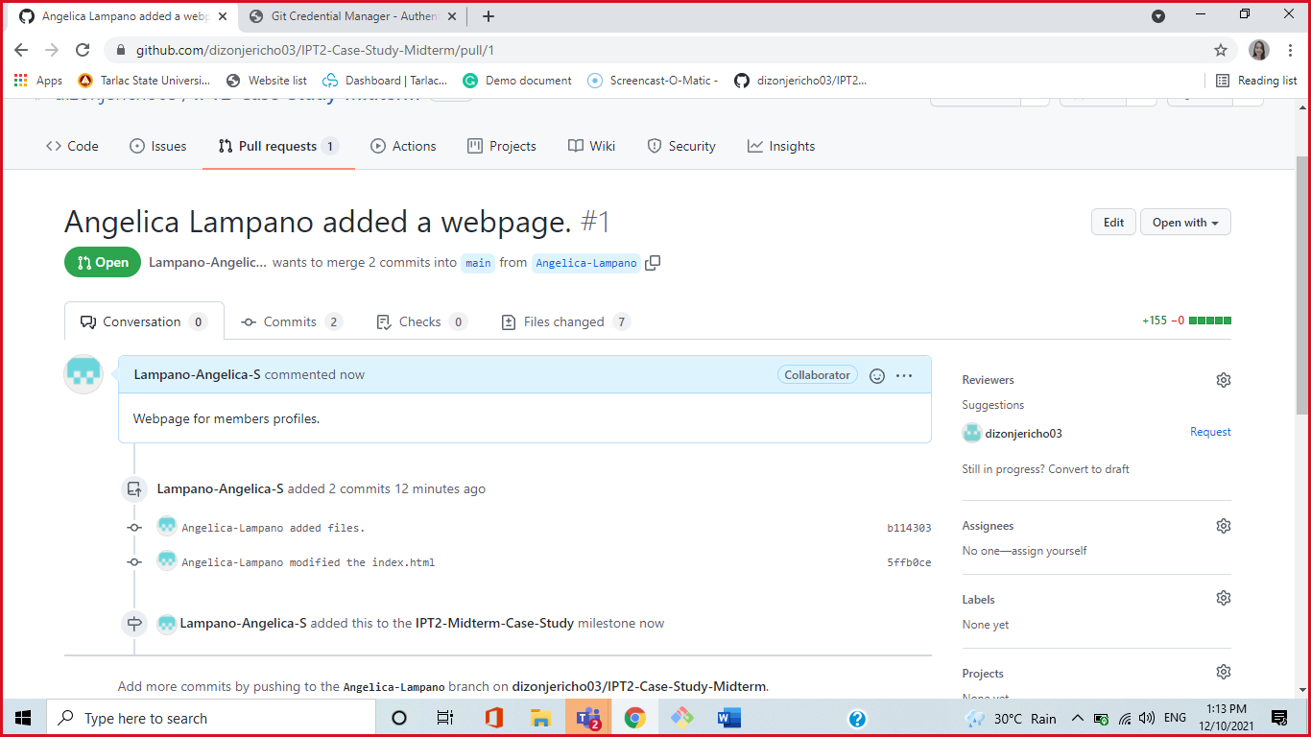

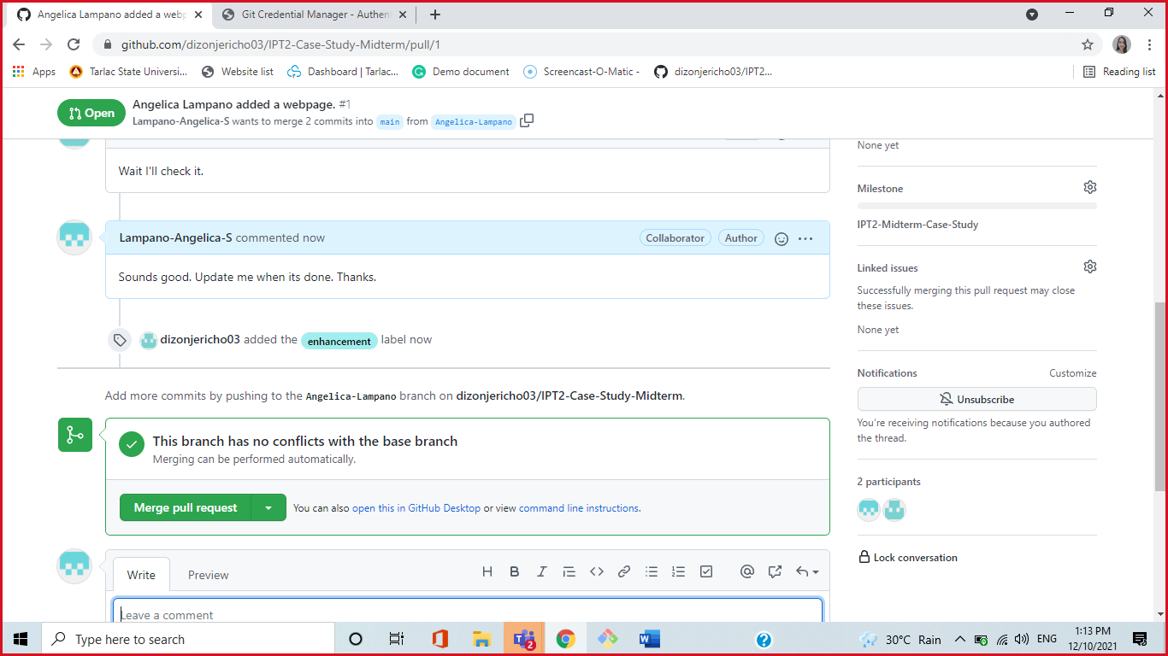

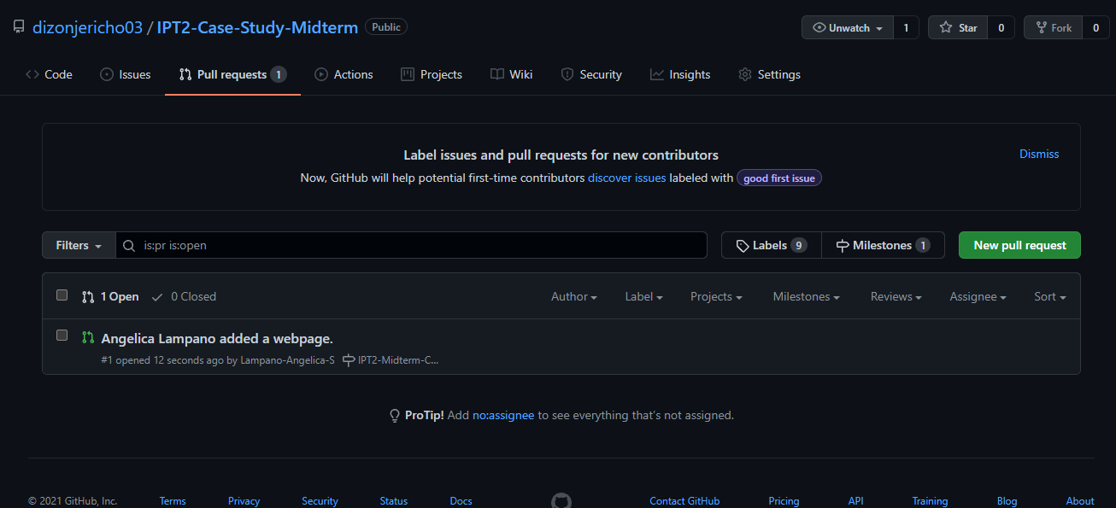

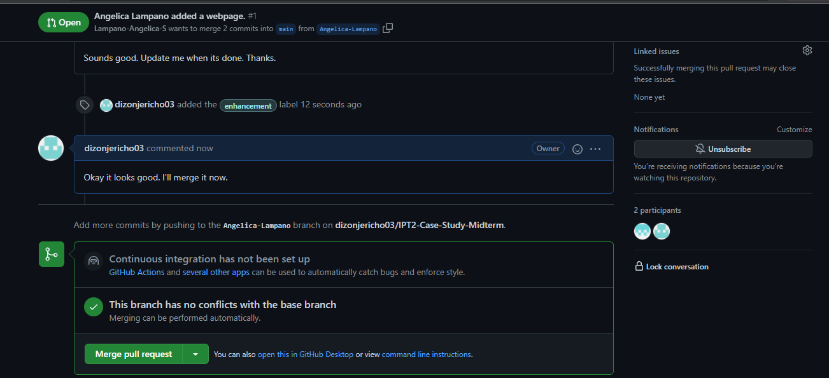

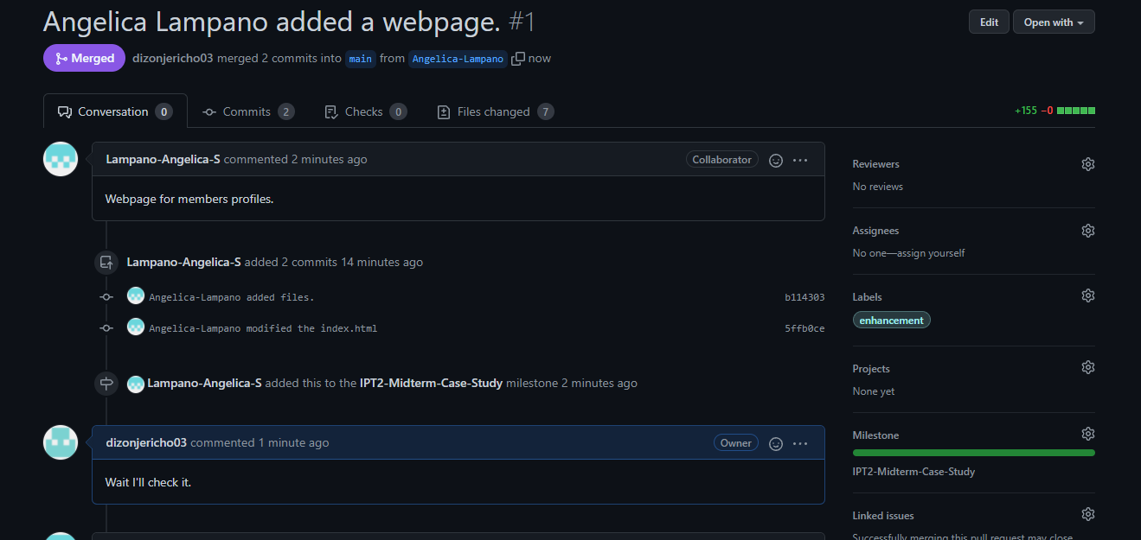

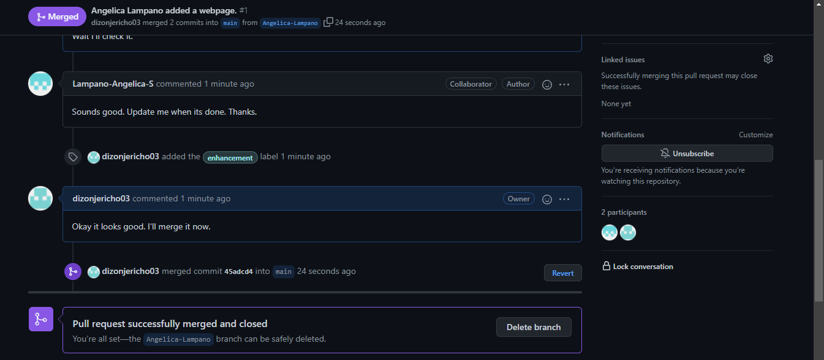

* **Niño-Caisip** **Pull Request** and **Create Pull Request** in GitHub.

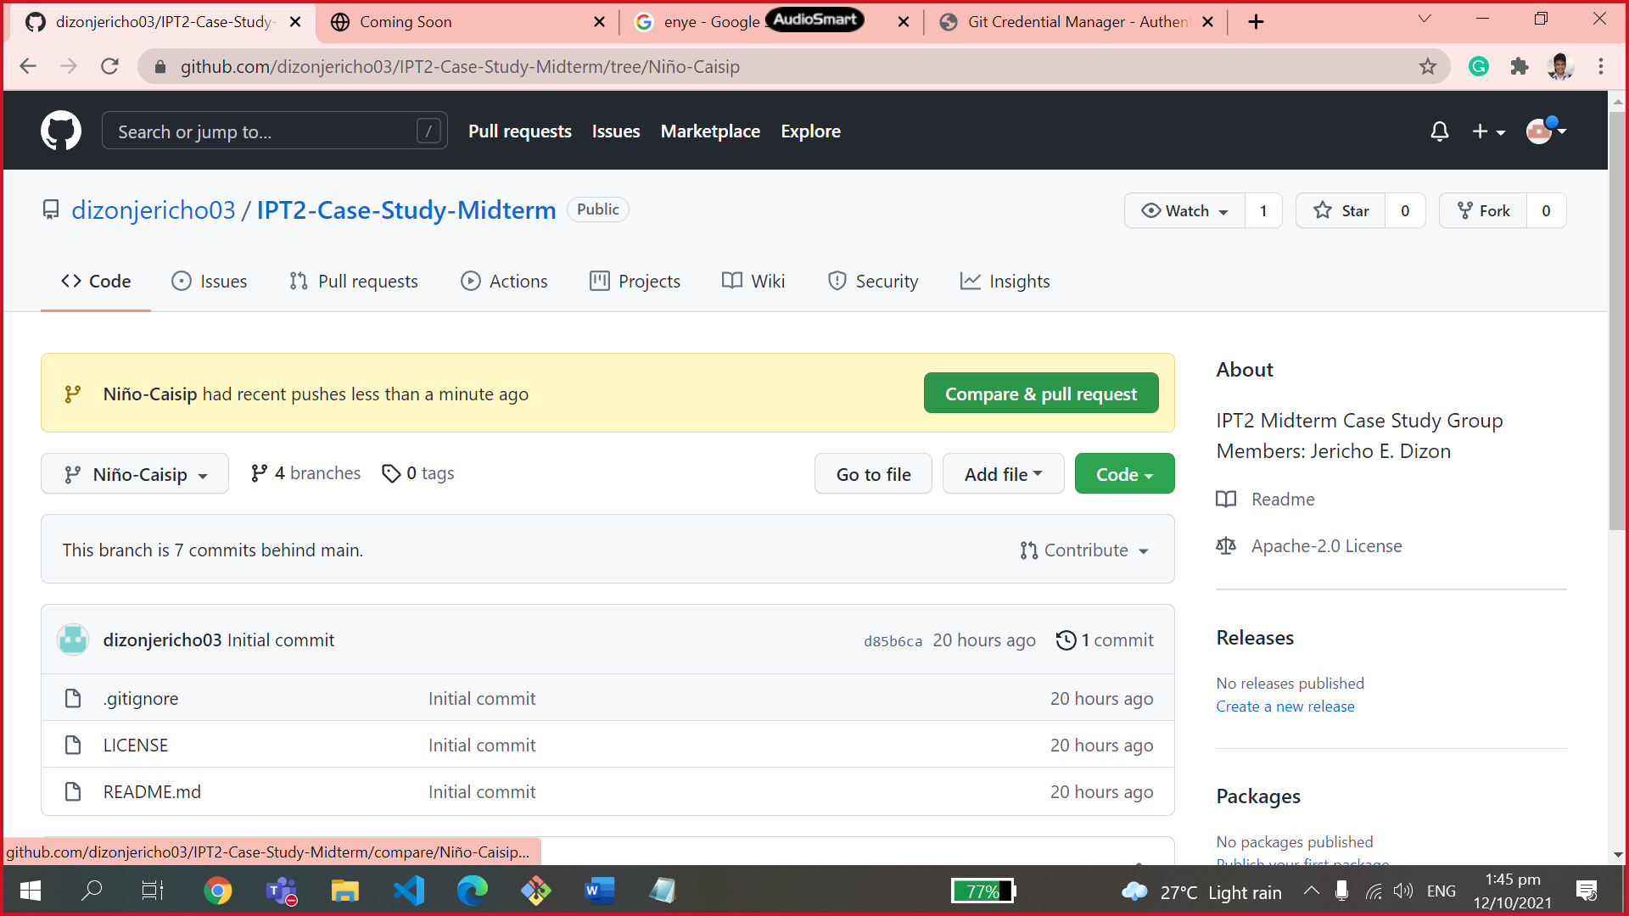

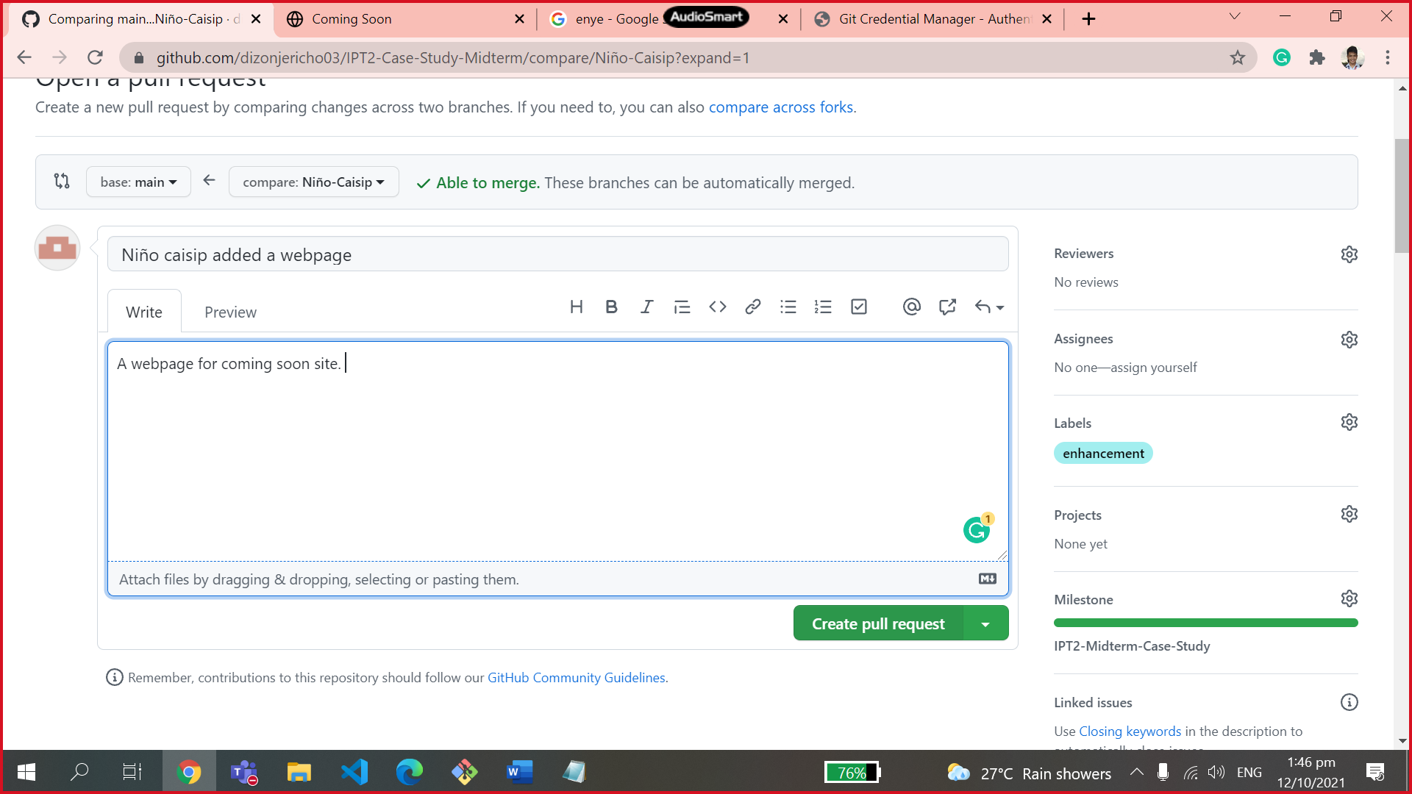

* **Niño-Caisip Merge Pull Request.**
* Comments and Successful Merge Pull Request.

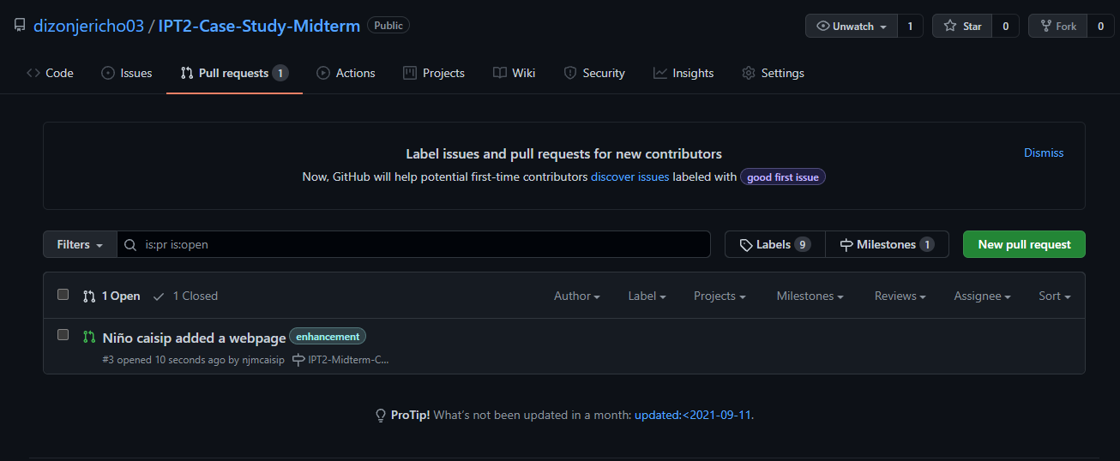

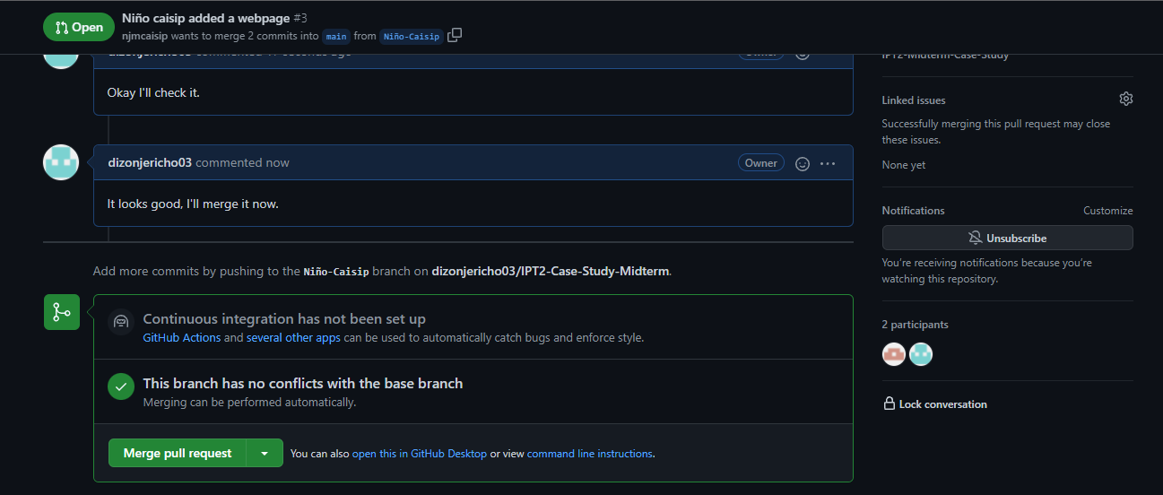

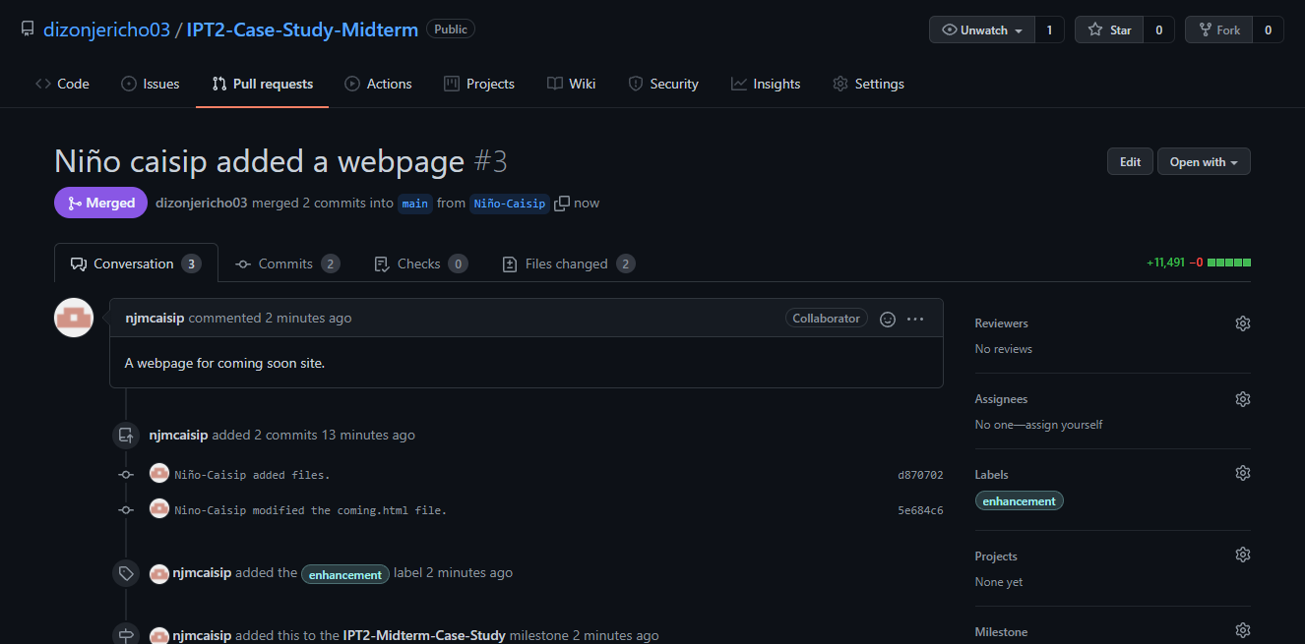

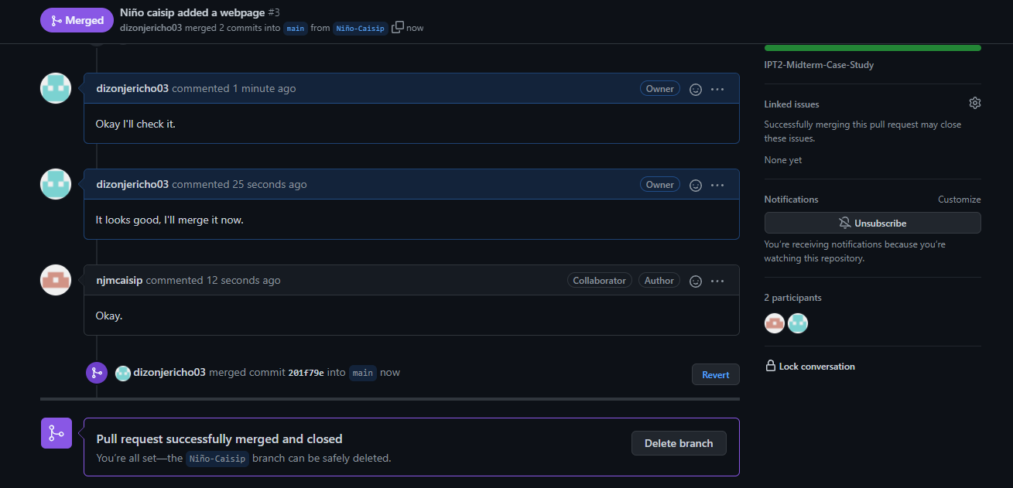

* **Jhazz-Zapanta** **Pull Request** and **Create Pull Request** in GitHub.

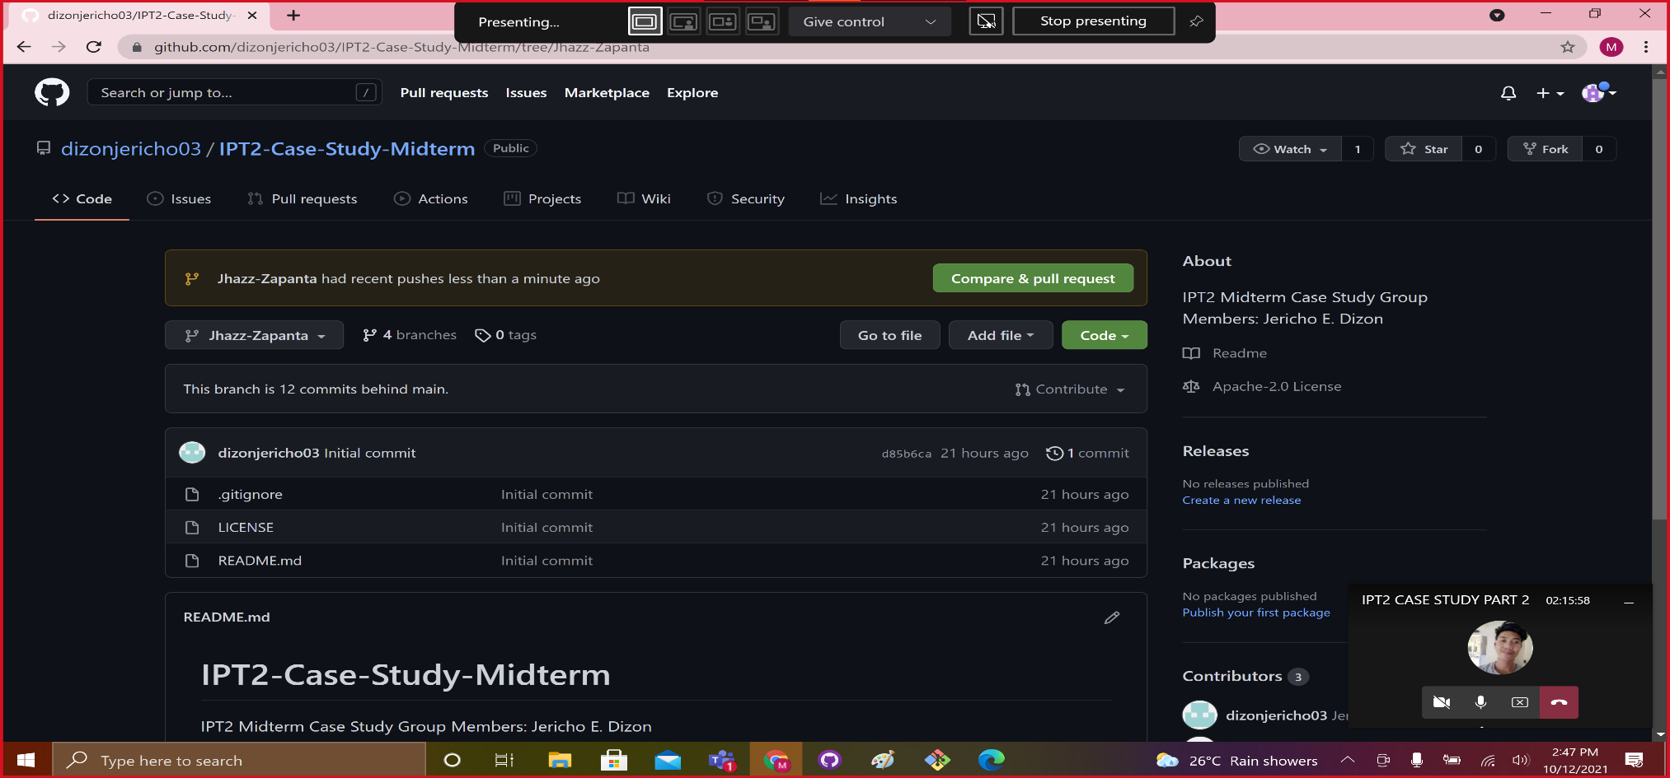

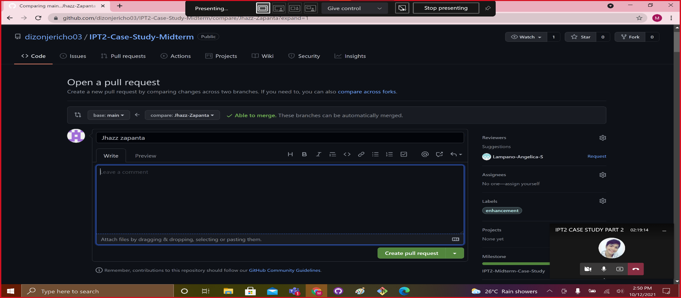

* **Jhazz-Zapanta Merge Pull Request.**
* Comments and Successful Merge Pull Request.

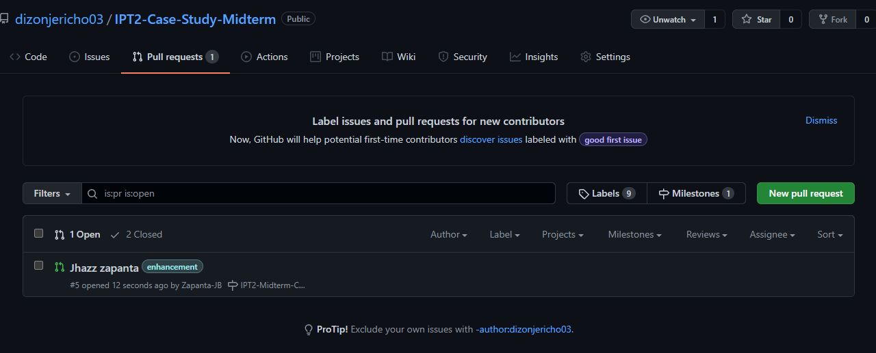

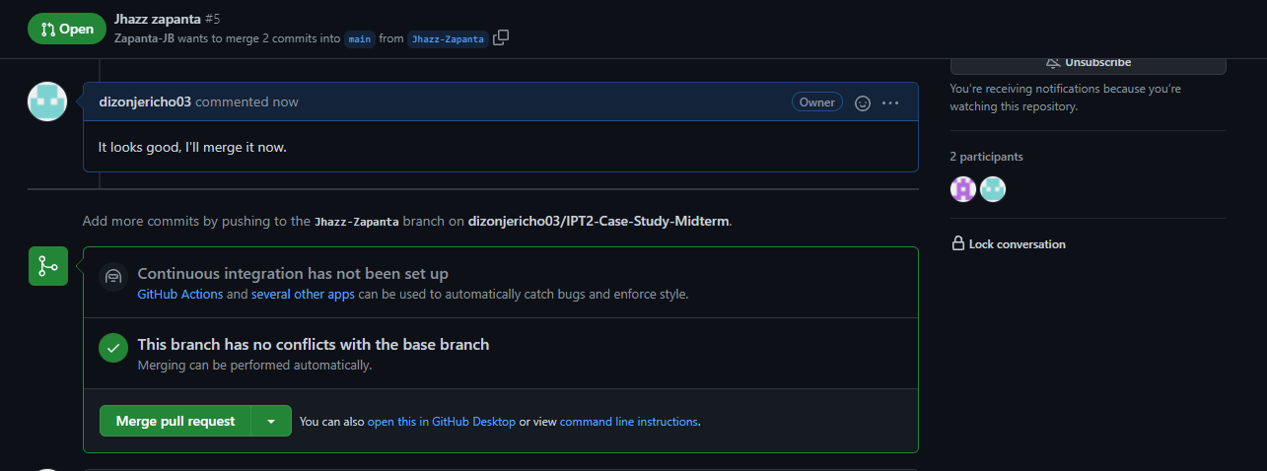

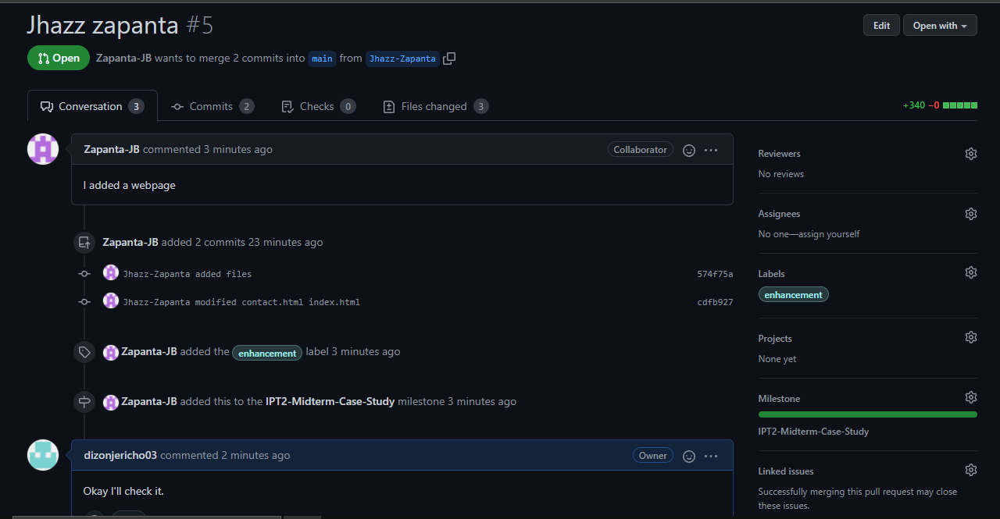

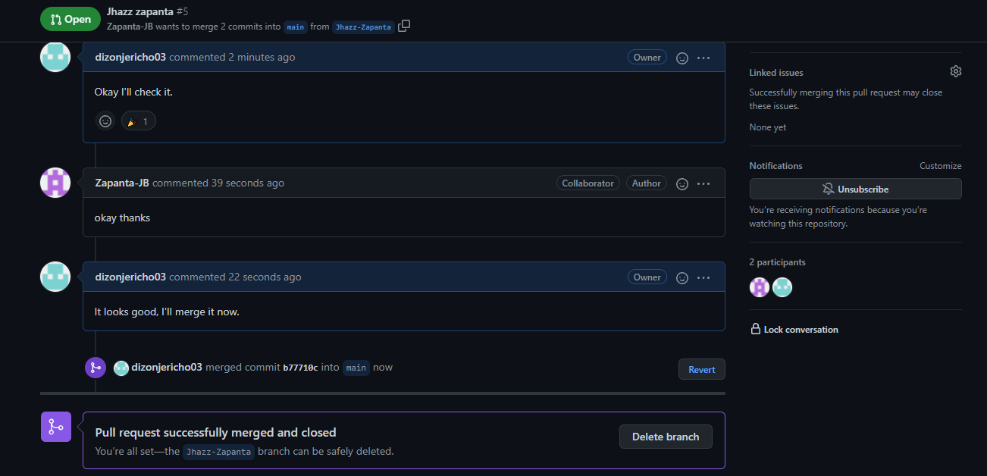

* Create an **Issue** for each member in GitHub.
* **Angelica-Lampano created issue.**

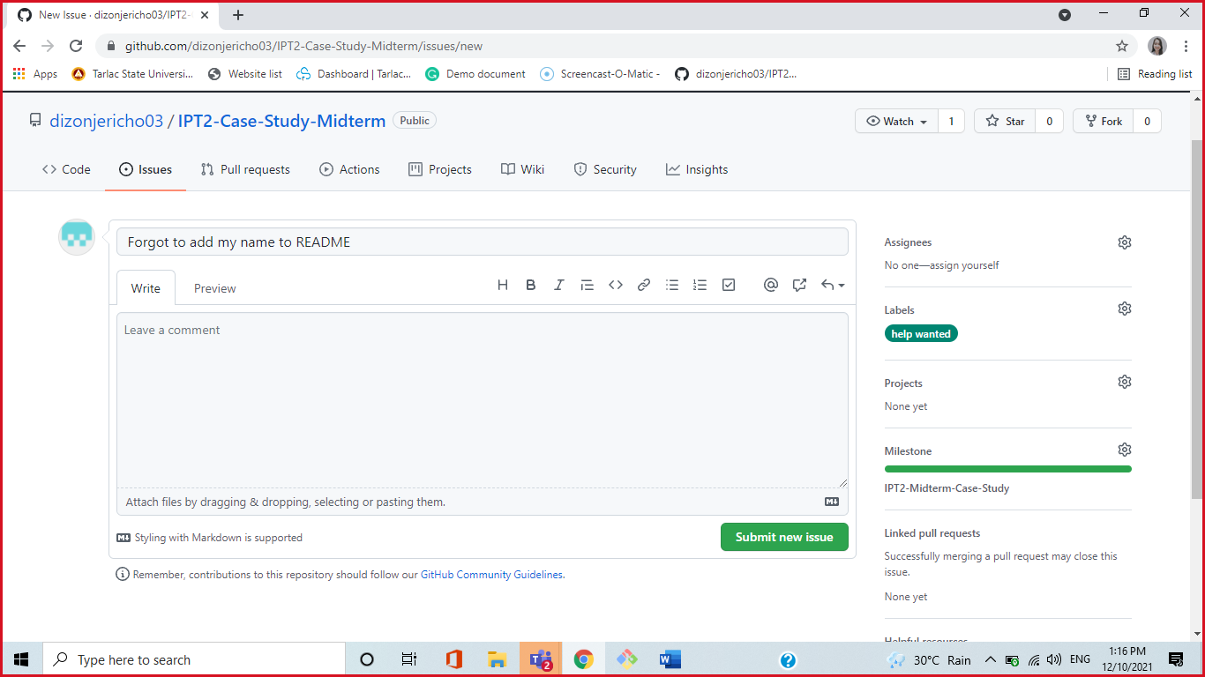

* **Updating the README for Angelica-Lampano issue.**

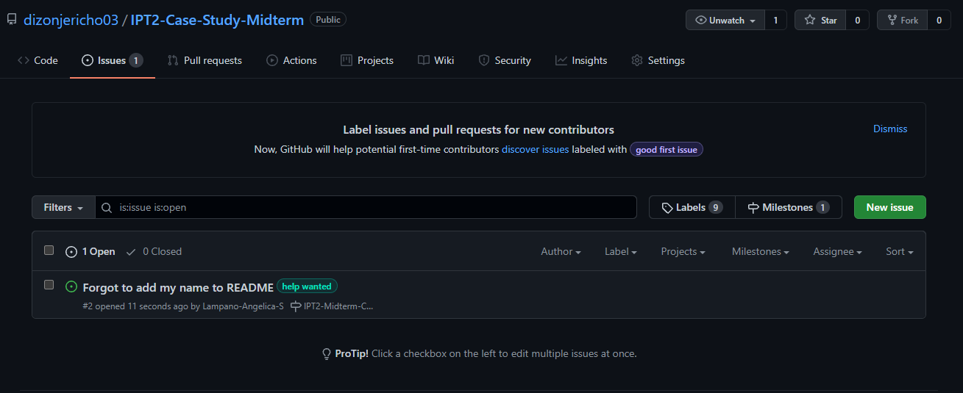

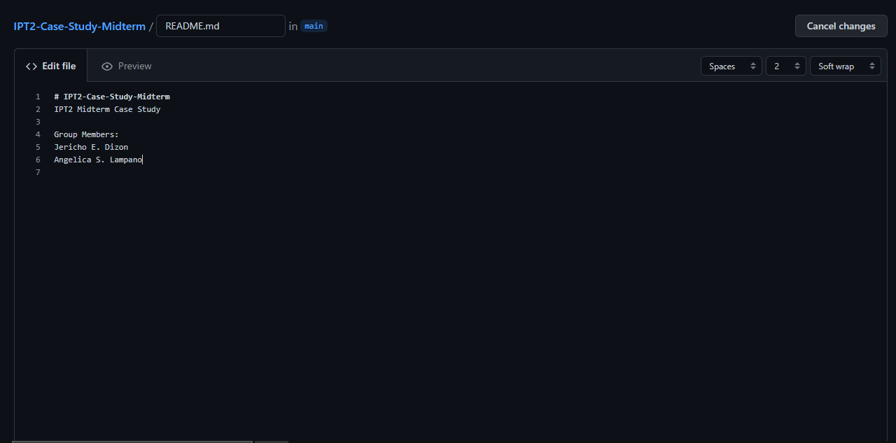

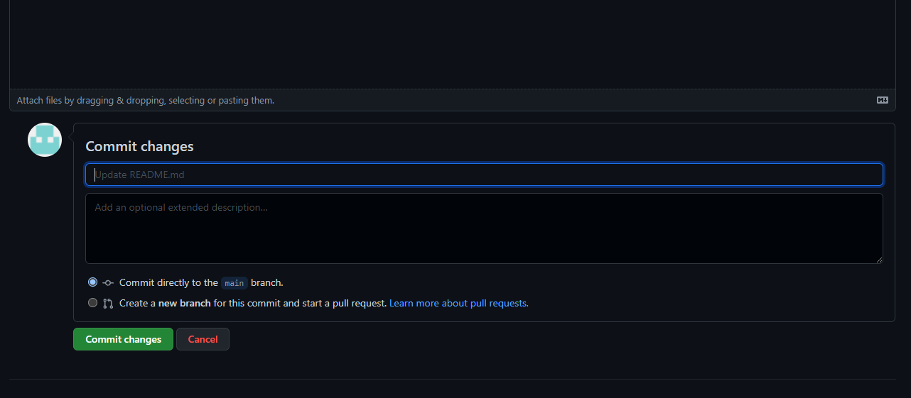

* **Angelica-Lampano Closed Issue.**

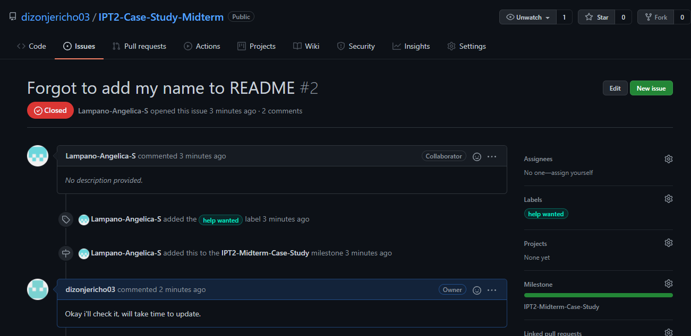

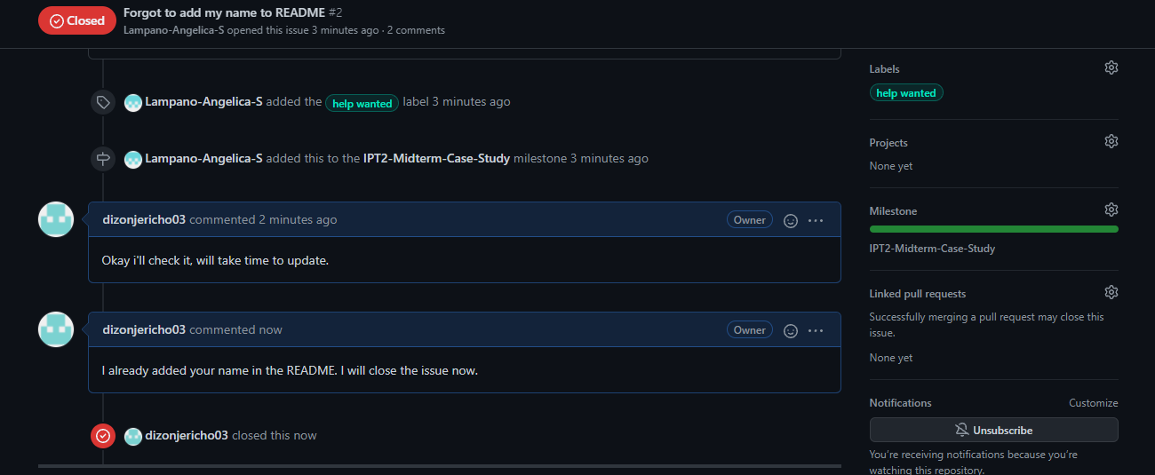

* **Niño-Caisip created issue.**

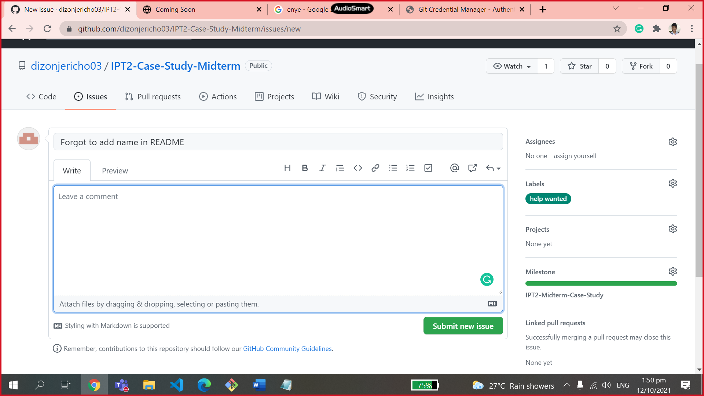

* **Updating the README for Niño-Caisip issue.**

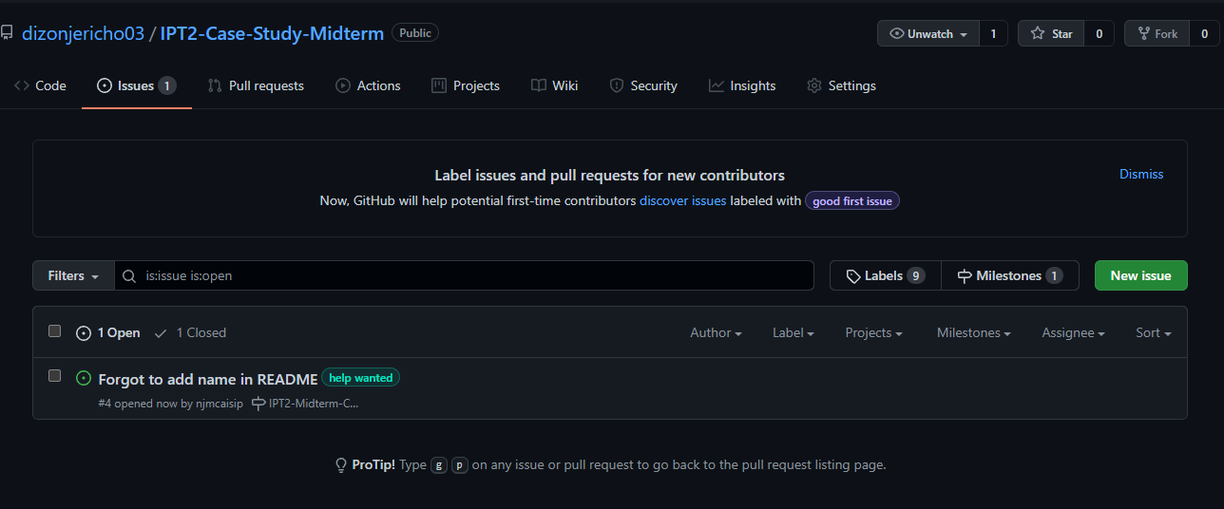

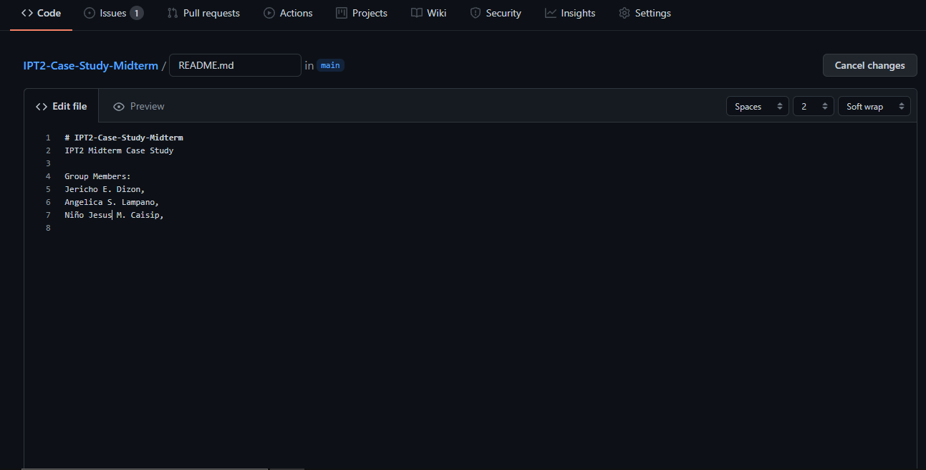

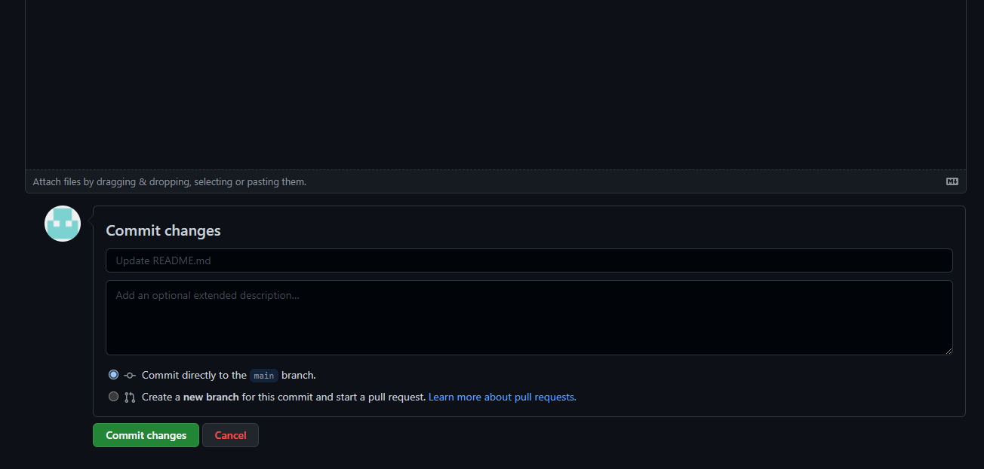

* **Niño-Caisip Closed Issue.**

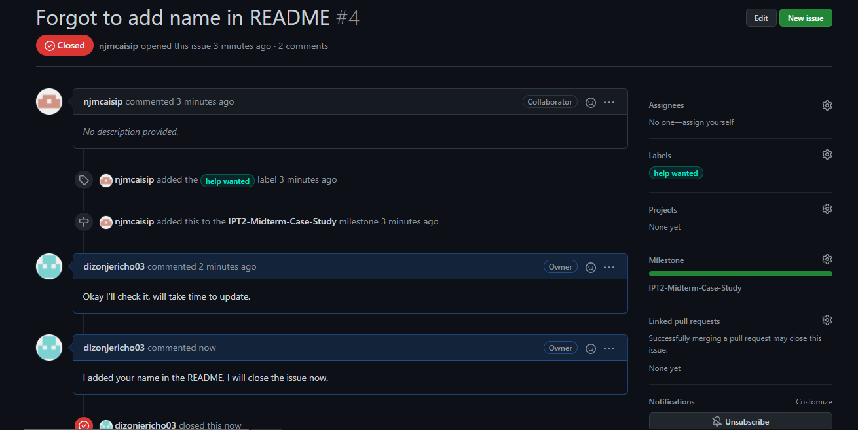

* **Jhazz-Zapanta created issue.**

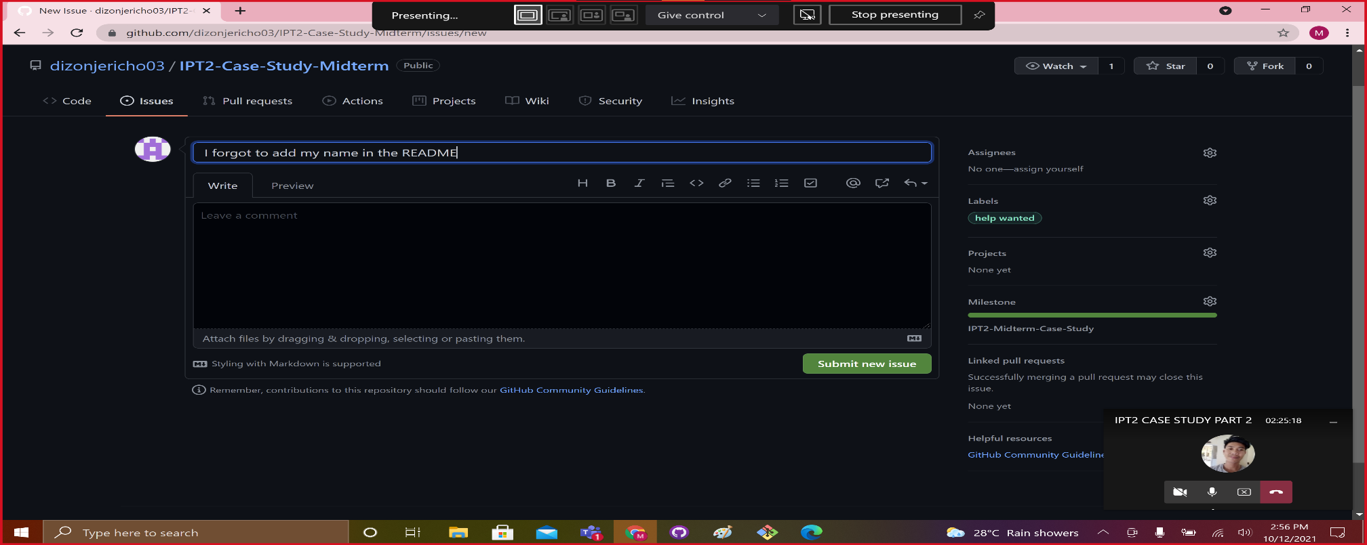

* **Updating the README for Jhazz-Zapanta issue.**

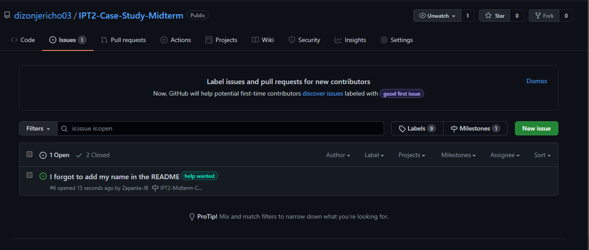

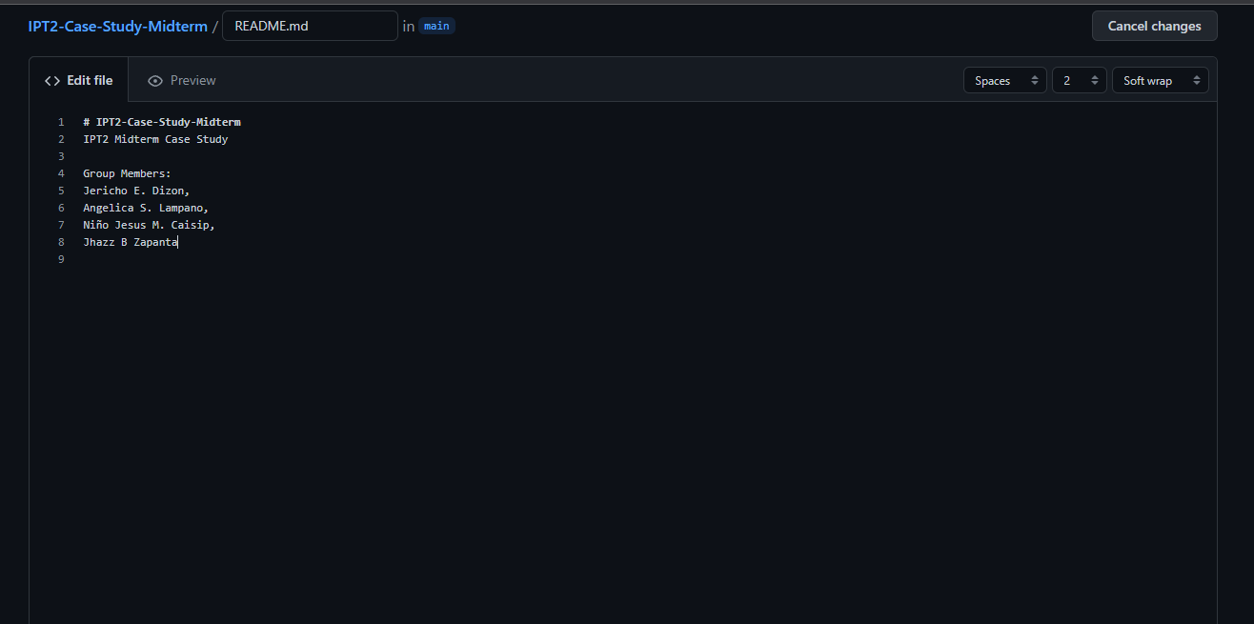

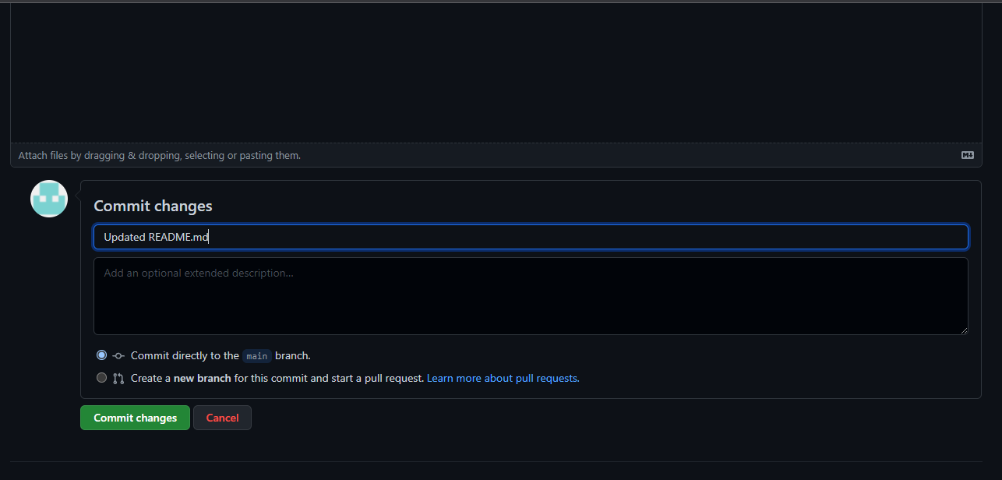

* **Jhazz-Zapanta Closed Issue.**

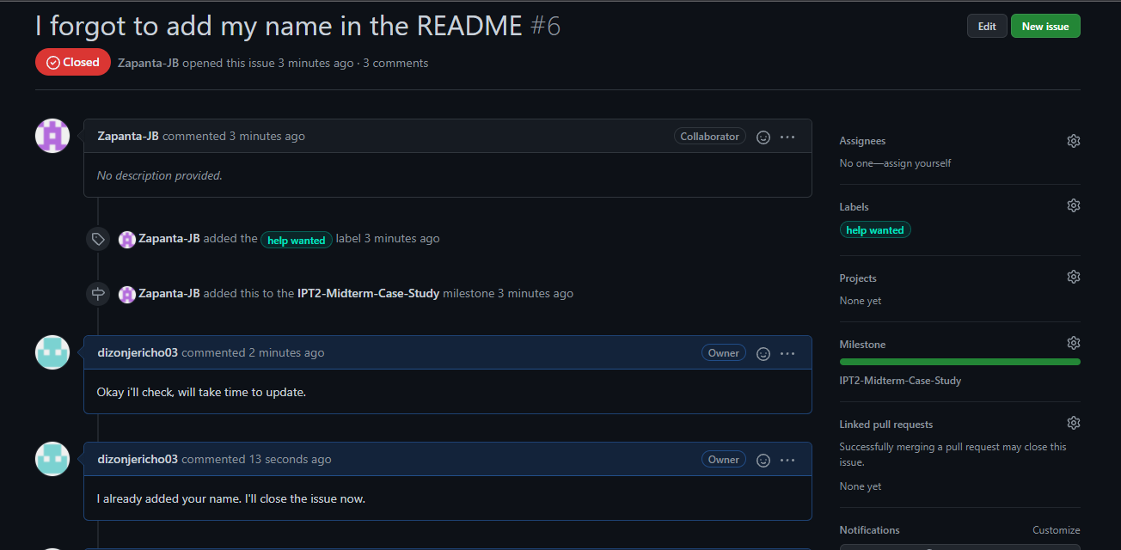

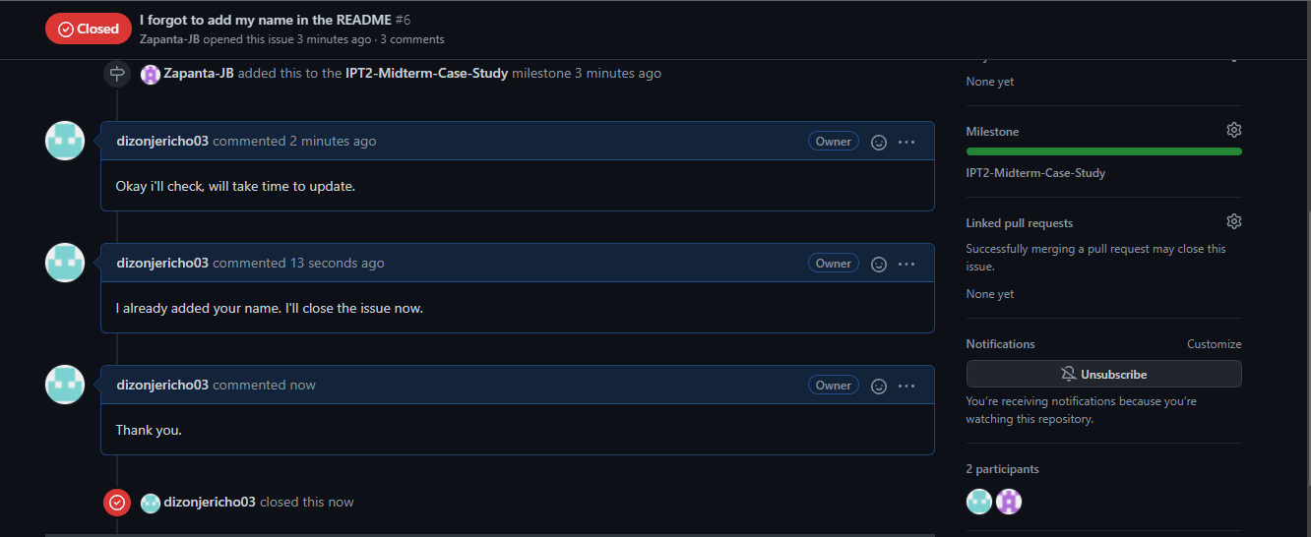

* Create a **Milestone** for the group in GitHub.
* **dizonjericho03 (main) Created a Milestone for IPT2-Case-Study-Midterm repository.**

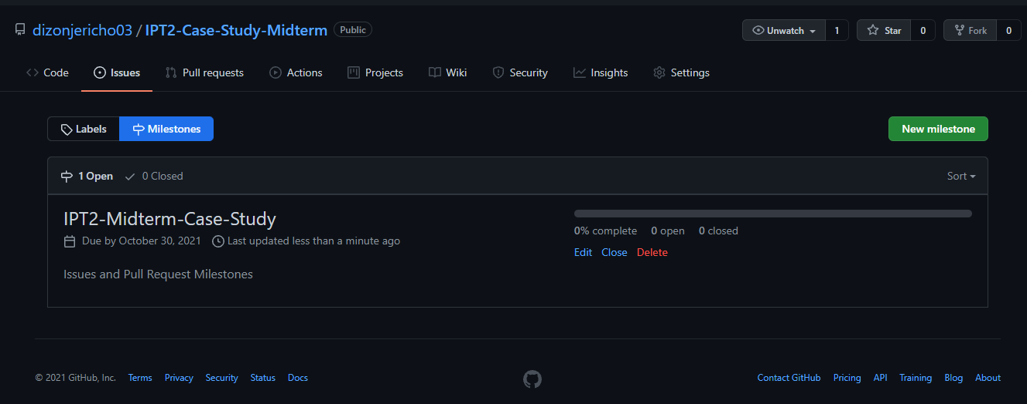

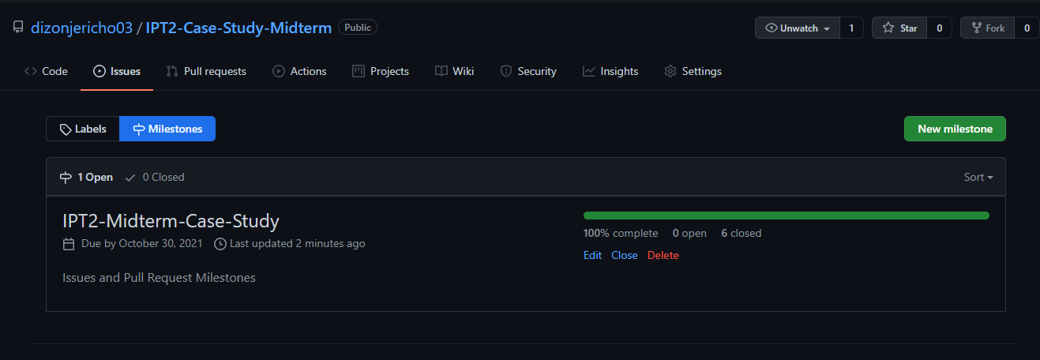

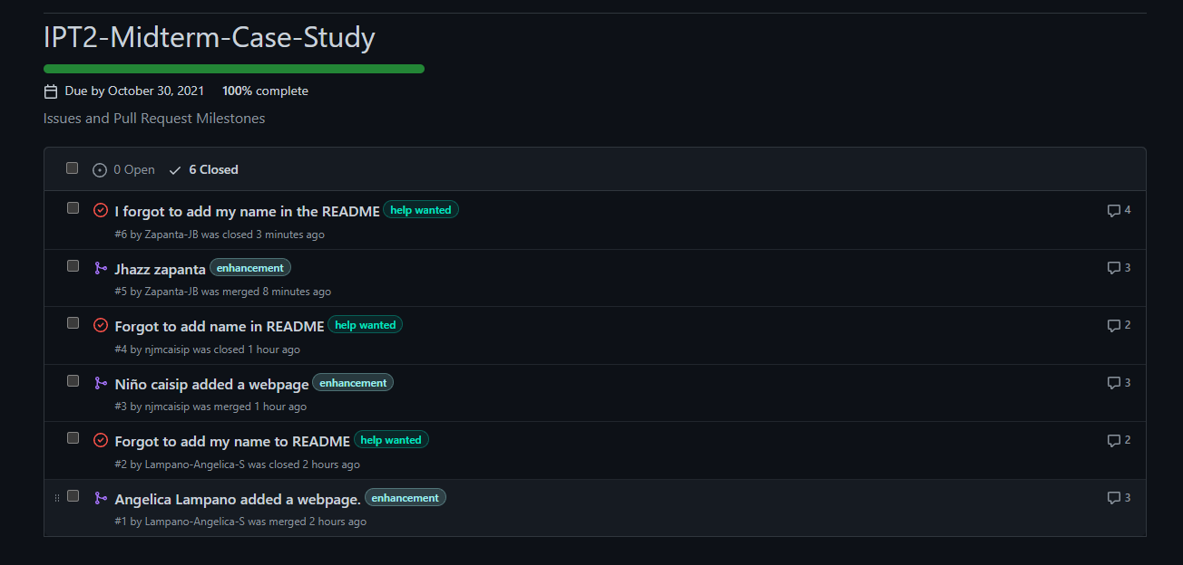

* Create a branch for each member and merge it with your master in GitHub.
* **Dizonjericho03 (main) Created branches for IPT2-Case-Study-Midterm.**

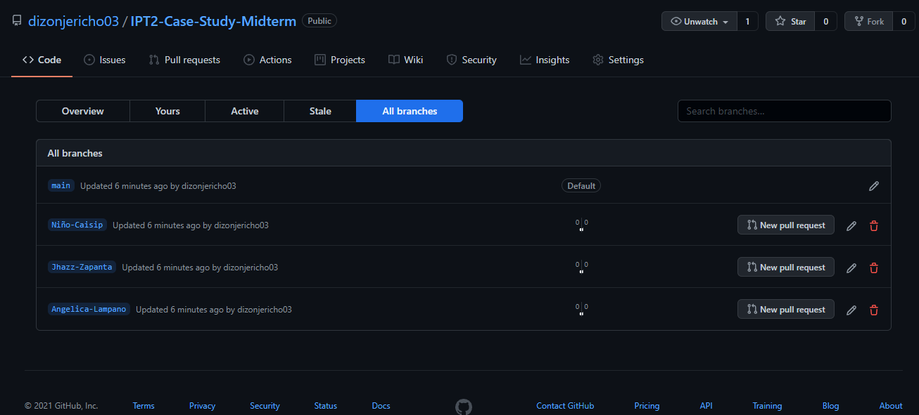

**Define and describe how you use of each command with screenshot in your case study.**

* **Git clone** - used to copy an existing Git repository into a new local directory [2].
* **Git Pull** - used to fetch and download content from a remote repository and immediately update the local repository to match that content [3].
* **Git Push** - used to upload local repository content to a remote repository [4].
* **Git Fetch** - downloads commits, files, and refs from a remote repository into your local repository [5].
* **Git Merge** - a command lets you take the independent lines of development created by git branch and integrate them into a single branch [6].
* **Issue** - track ideas, feedback, tasks, or bugs for work on GitHub [7].
* **Pull Request** - let you tell others about changes you've pushed to a branch in a repository on GitHub [8].
* **Milestone** - to track progress on groups of issues or pull requests in a repository [9].
* **Branch** - allow you to develop features, fix bugs, or safely experiment with new ideas in a contained area of your repository [10].
* **Git clone** - Using git clone the main branch cloned his remote repository to the local repository.



* **Git Pull** - Using git pull it downloads the changes from the remote and merges them into your current branch and local repository.



* **Git Push** - Using git push origin HEAD:main, I pushed the added files from my local repository to the remote repository in GitHub.



* **Git Fetch** - Using git fetch it downloads the changes from the remote to your local repository.



* **Git Merge** - Merged the main branch with another branch.



* **Issue** - with issue I can get feedback from the other members and track the progress of our study.







* **Pull Request** – with pull request other members can notify the main branch about their recent changes they pushed to their branch and main branch can check it if it was okay to merge it.







* **Milestone** – with milestone we can track the progress of our study.





* **Branch** – it allows us to push changes to a certain branch without affecting the main branch.



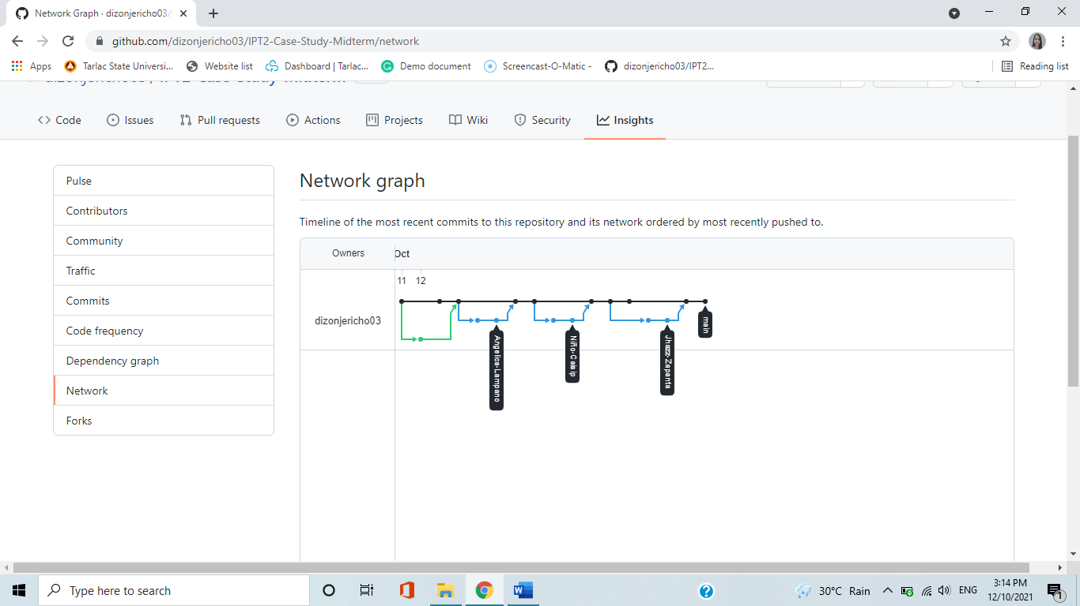

**Note: List the contributions of your group members**

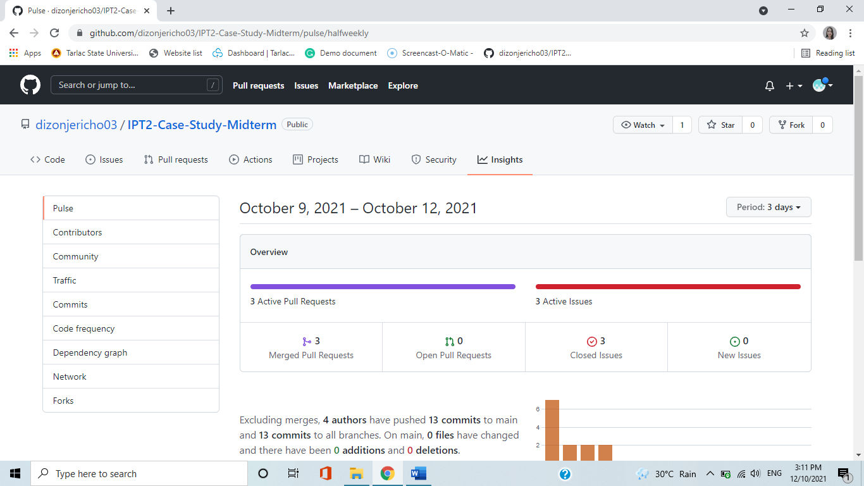

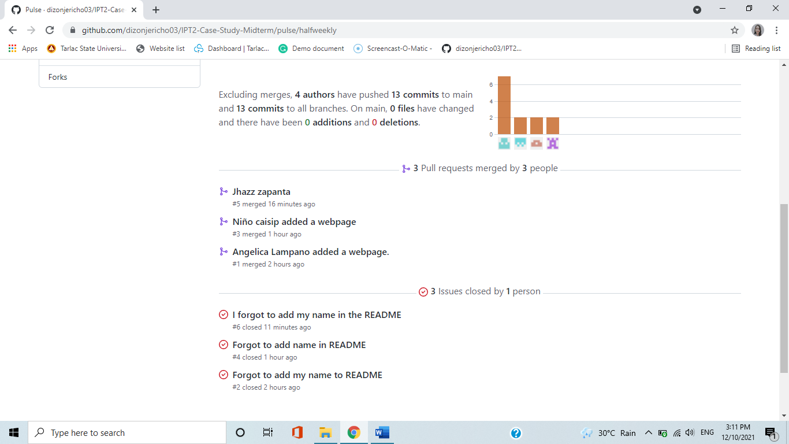

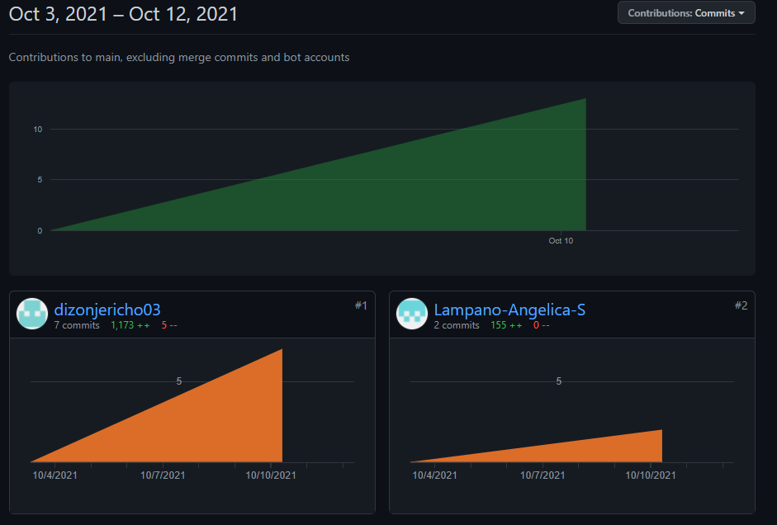

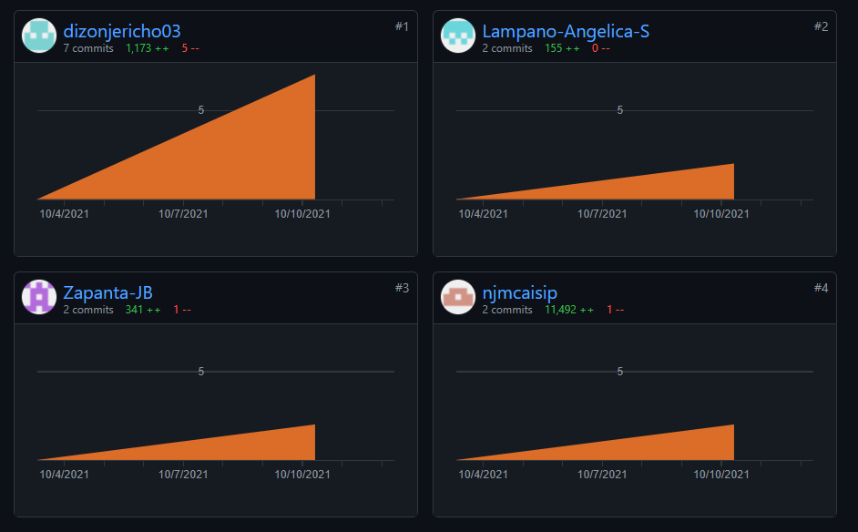

**Jericho E. Dizon**

* Created IPT2-Case-Study-Midterm repository.
* Invited other members as collaborator.
* Created Branch for the members.
* Added 5 webpages from the git local repository and push to the GitHub repository.
* Merge Pull Request.
* Respond to the issues of the members.

**Angelica S. Lampano**

* Accepted collaborator request.
* Added 1 webpage for collaborators profile from the git local repository and push to the GitHub repository.
* Created a Pull Request.
* Created an Issue.

**Niño Jesus M. Caisip**

* Accepted collaborator request.
* Added 1 webpage for webpage “coming soon” feature from the git local repository and push to the GitHub repository.
* Created a Pull Request.
* Created an Issue.

**Jhazz B. Zapanta**

* Accepted collaborator request.
* Added 1 webpage for collaborators contact from the git local repository and push to the GitHub repository.
* Created a Pull Request.
* Created an Issue.

## B.2 Documentation

* **Jericho E. Dizon (main)**
* Using git clone the main branch cloned his remote repository to the local repository.



* Using git fetch it downloads the changes from the remote to your local repository.
  + Created a branch in the local repository using git checkout -b.
  + Using git pull it downloads the changes from the remote and merges them into your current branch and local repository.





* Added the files from the 5 webpages and used git add and git commit -m.



* Merged the main branch with another branch using the git merge –no-ff dizon-main -m “message” command.



* Using git log we will see the commits of the other branches.



* Using git push origin HEAD:main, I pushed the added files from my local repository to the remote repository in GitHub.



* **Angelica S. Lampano (Angelica-Lampano)**
* Open the git bash command line.
* Set and configure your username and user email..

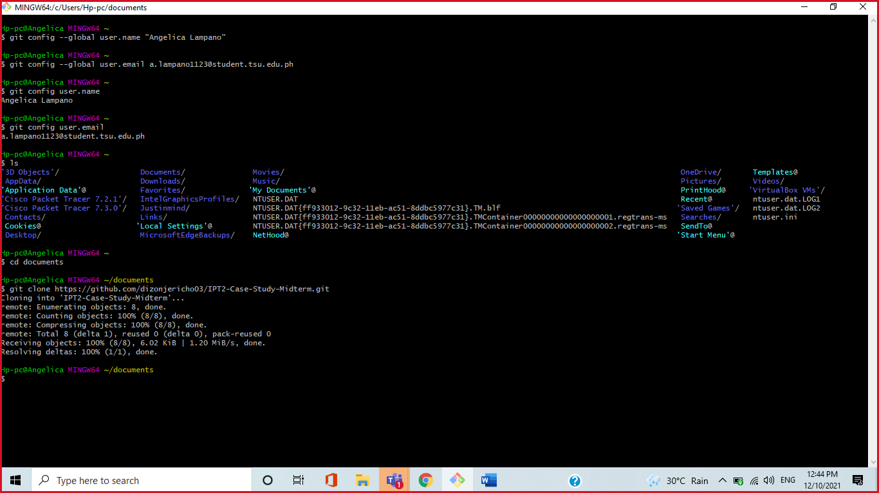

* Go to GitHub and copy the repository link.

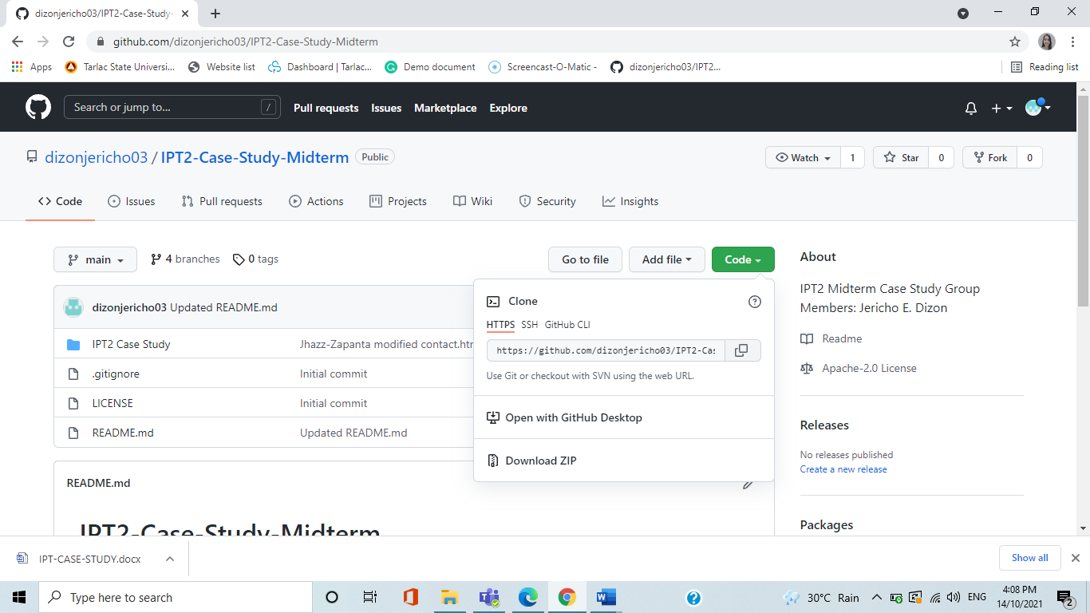

* Check the current folder using ls command.
* Type cd document.

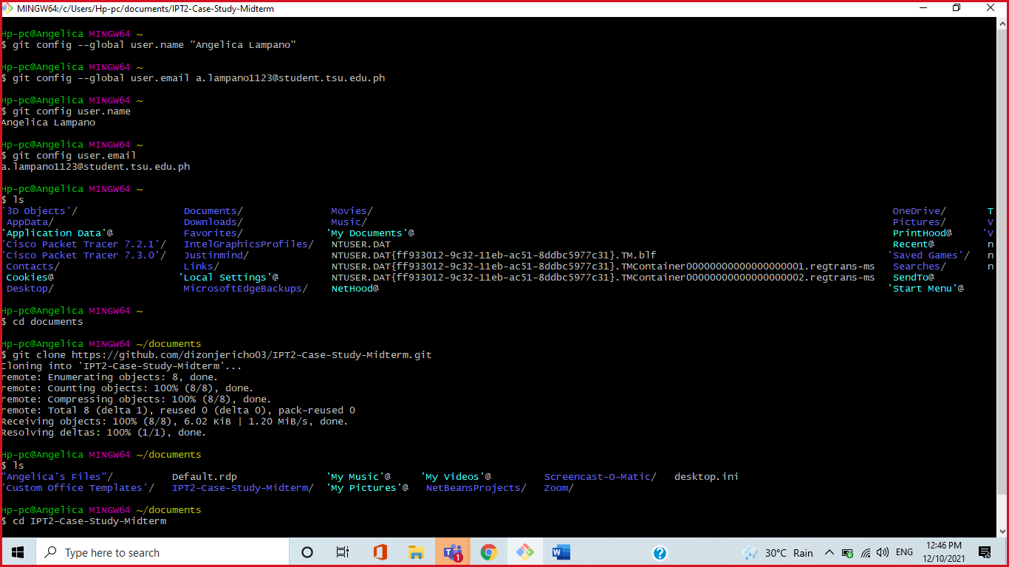

* Create a file to a repository.

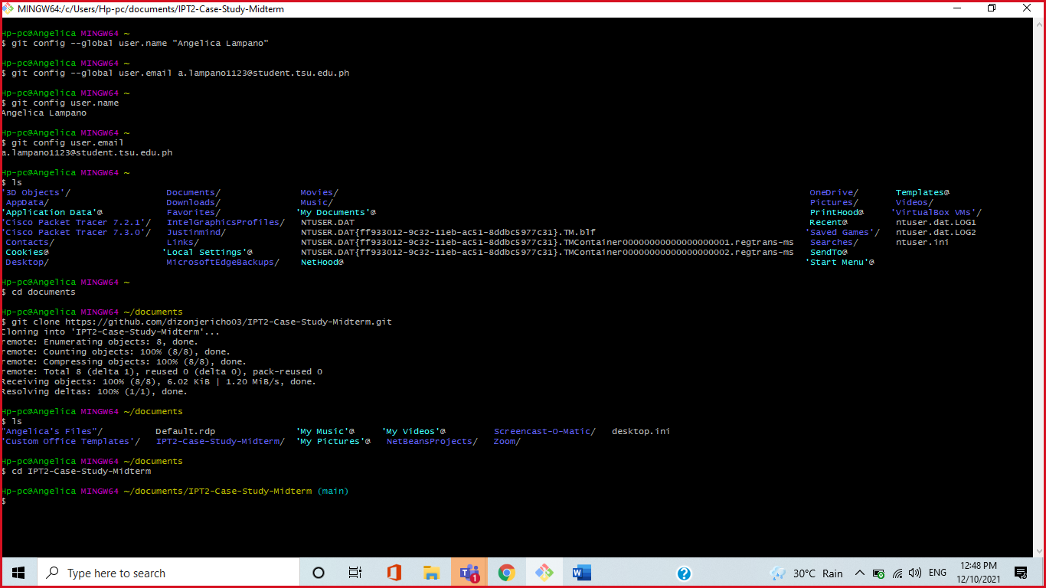

* Fetch and pull the remote repository

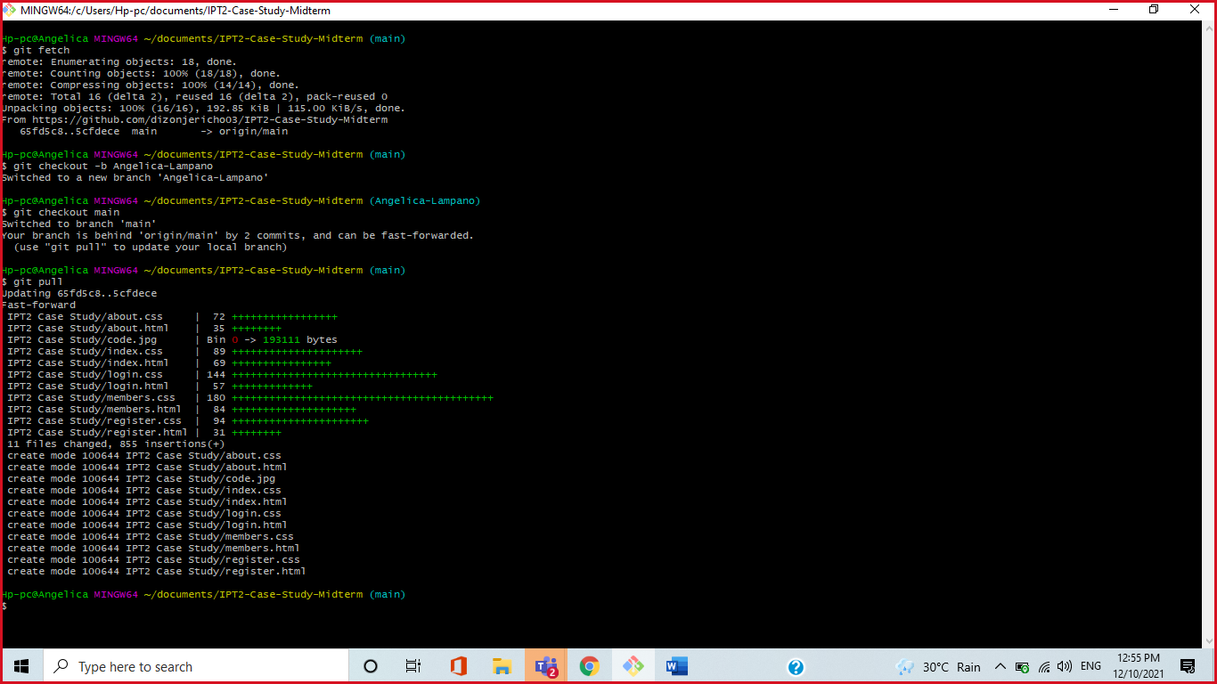

* Add file to repository
* Commit and create a message or comment.
* Check the status of your branch

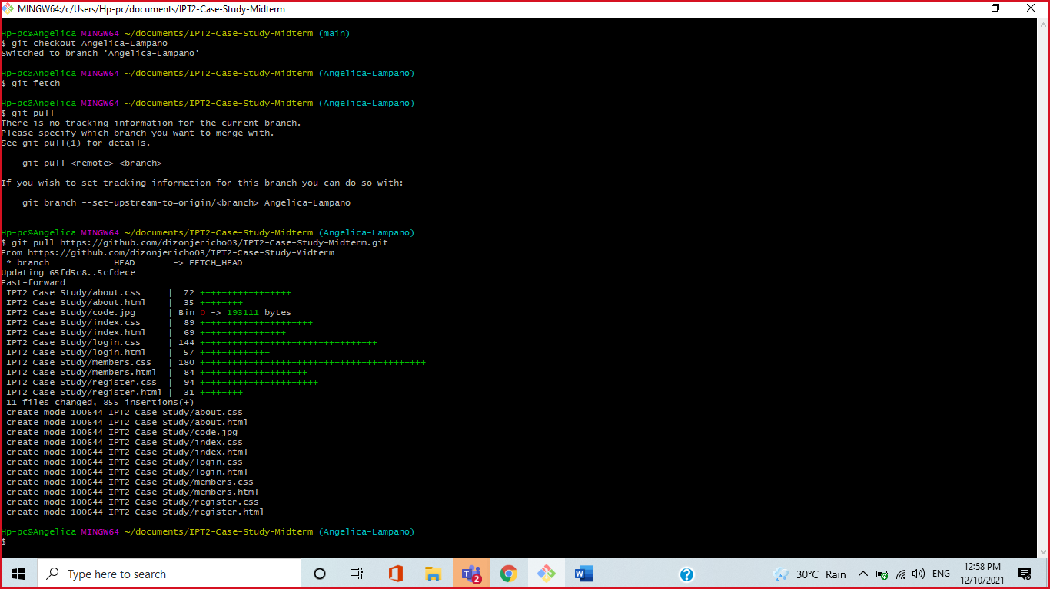

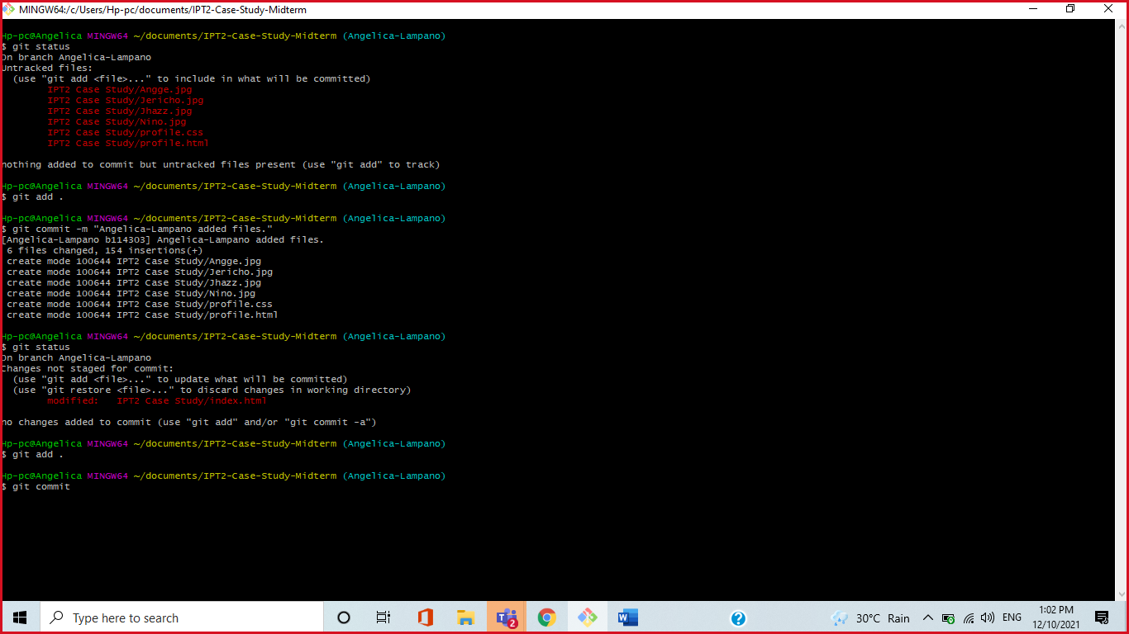

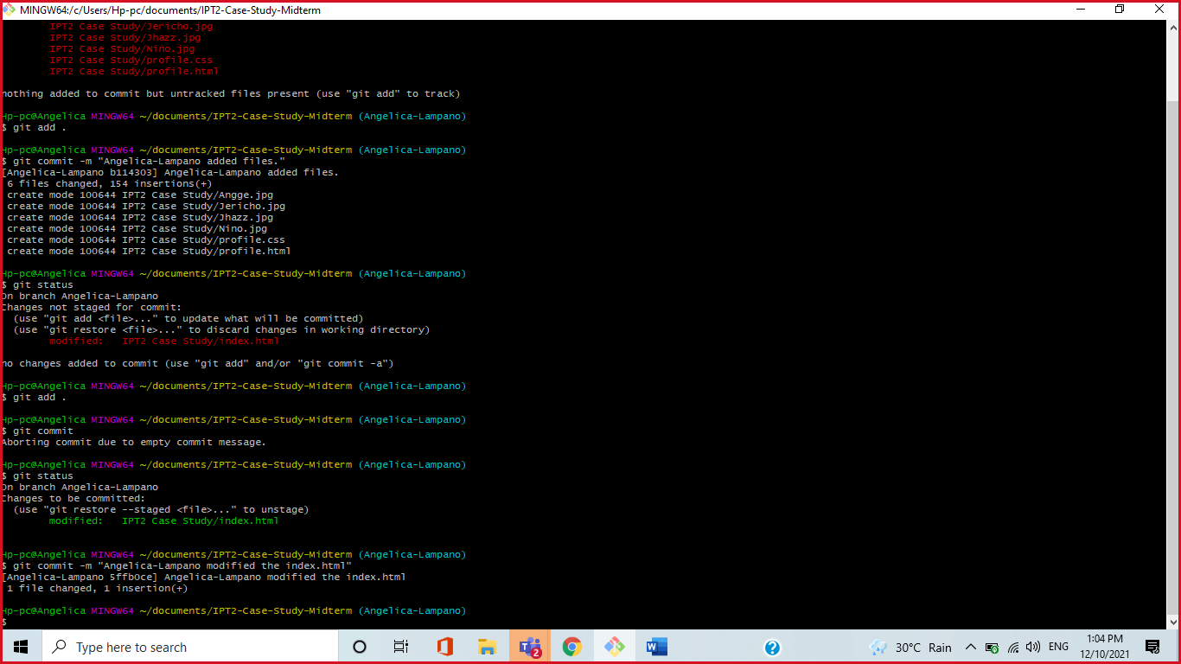

* Check and show all the list of all the commits made to a repository by using git log command.

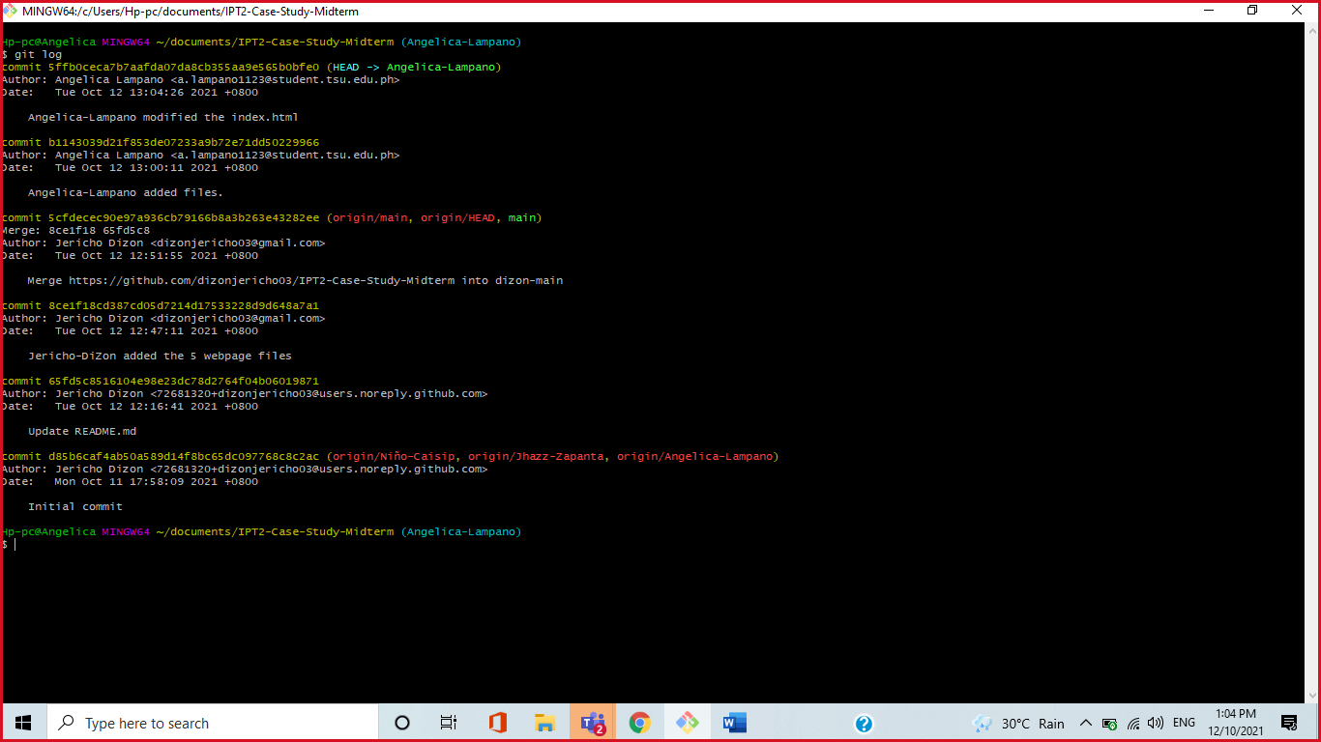

* Check out the branch you want to use.
* Merged the main branch with another branch using the git merge --no-ff Angelica-Lampano -m “message” command.

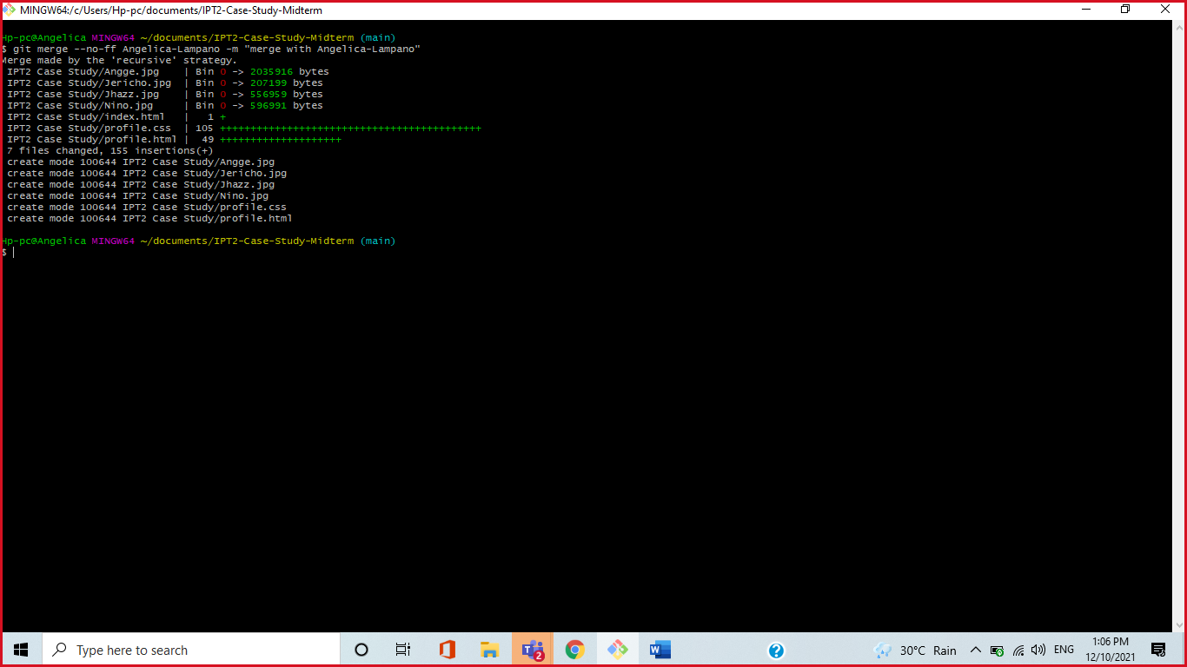

* Check and show all the list of all the commits made to a repository by using git log command.

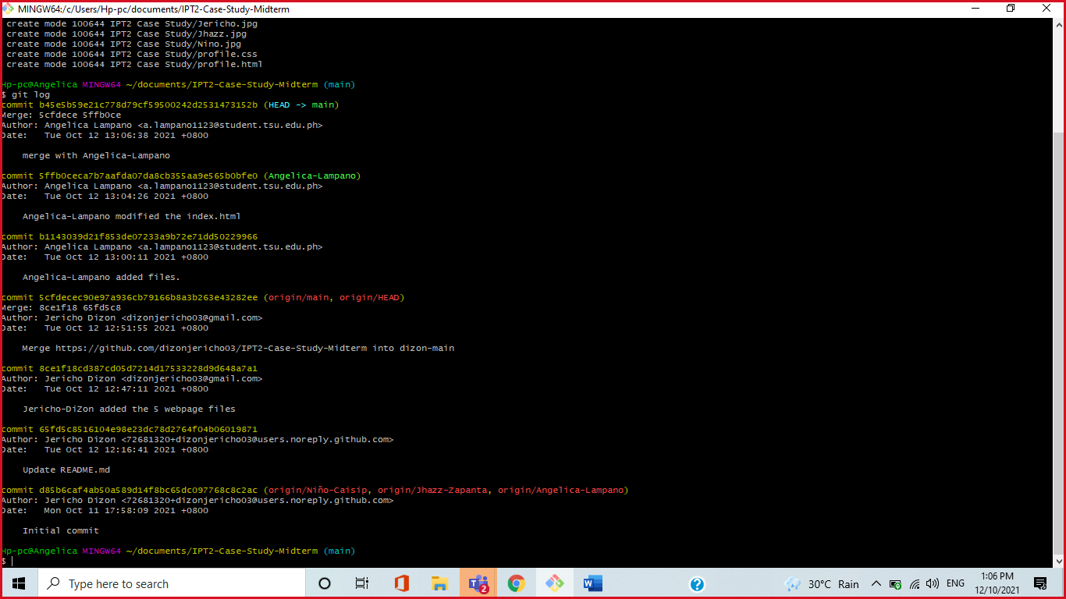

* Check out to your own branch.
* Push all the added files from own local repository to the remote repository in GitHub.

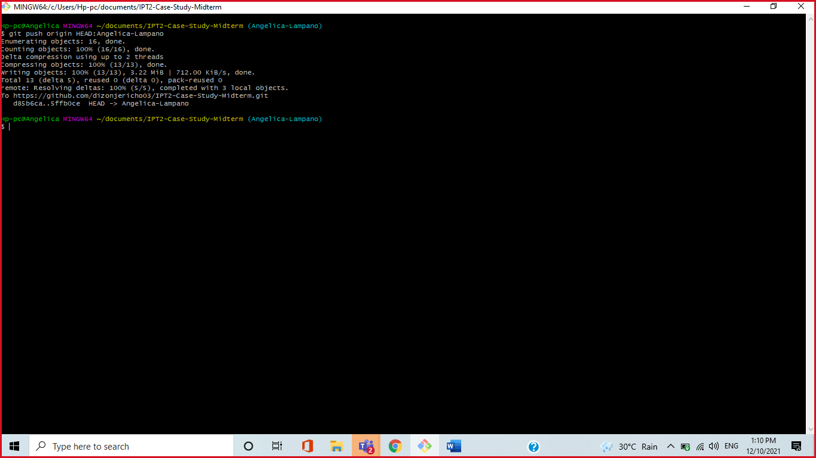

* Navigate to the original GitHub repository, and you should see a big green button marked "Compare and pull request".



* Click that button and you will be taken to a page giving you the opportunity to describe your pull request and showing you the changes, you have made.



* Create an issue from a repository
* Under your repository name, click “ISSUES”
* Click New Issue
* Type a title and description for your issue.
* When you're finished, click **Submit new issue**.



* **Niño Jesus M. Caisip (Niño-Caisip)**
* Open the git bash command line.
* Set and configure your username and user email.

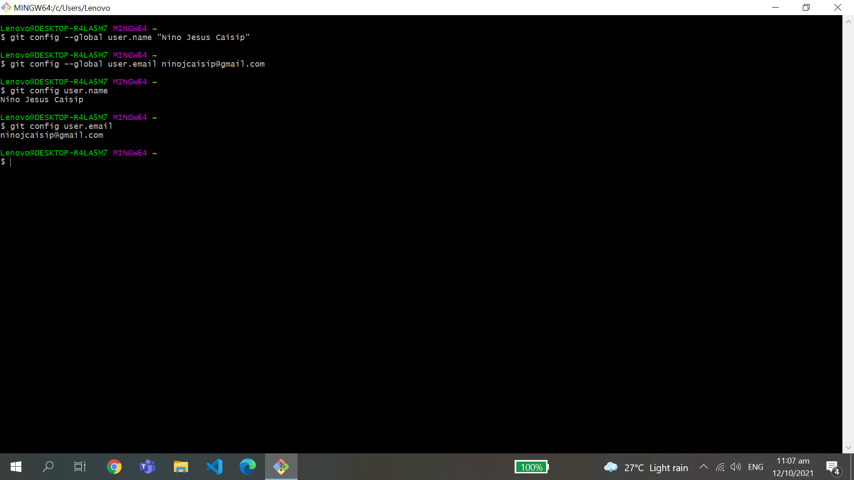

* Go to GitHub and copy the repository link.

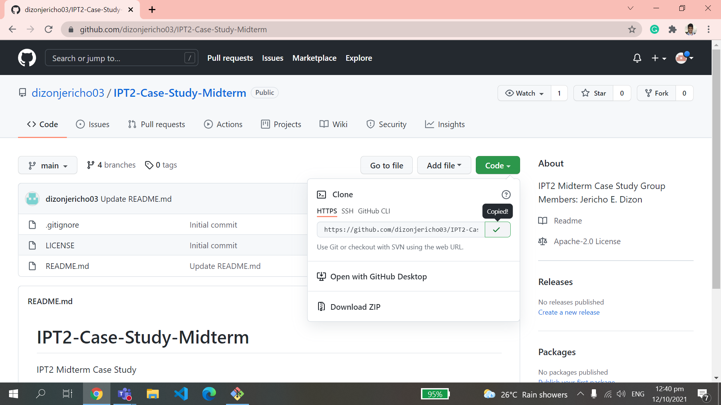

* Check the current folder using ls command.
* Type cd document.

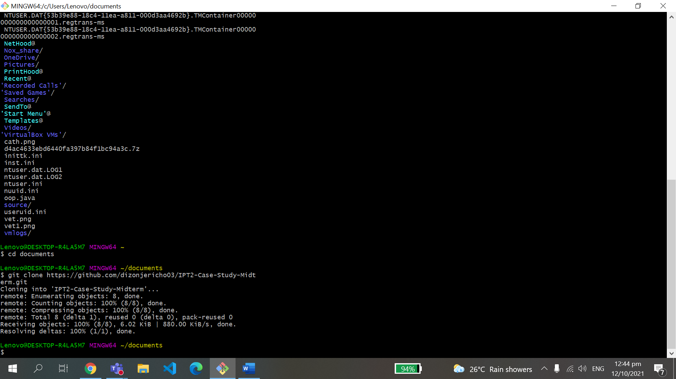

* Create a file to a repository.

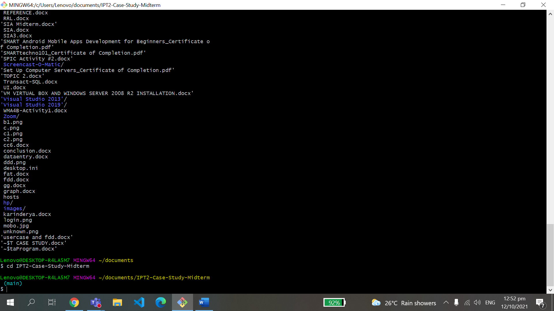

* Fetch and pull the remote repository

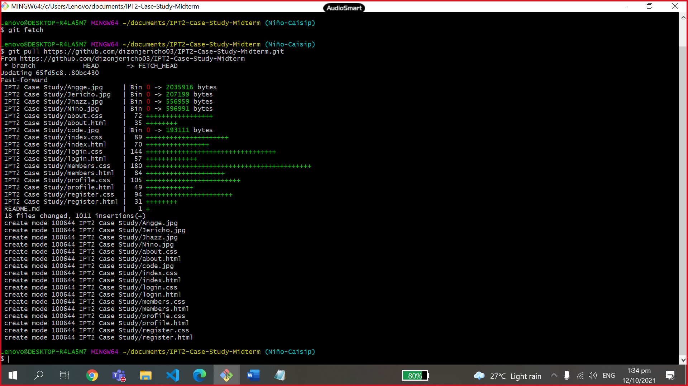

* Add file to repository
* Commit and create a message or comment.
* Check the status of your branch

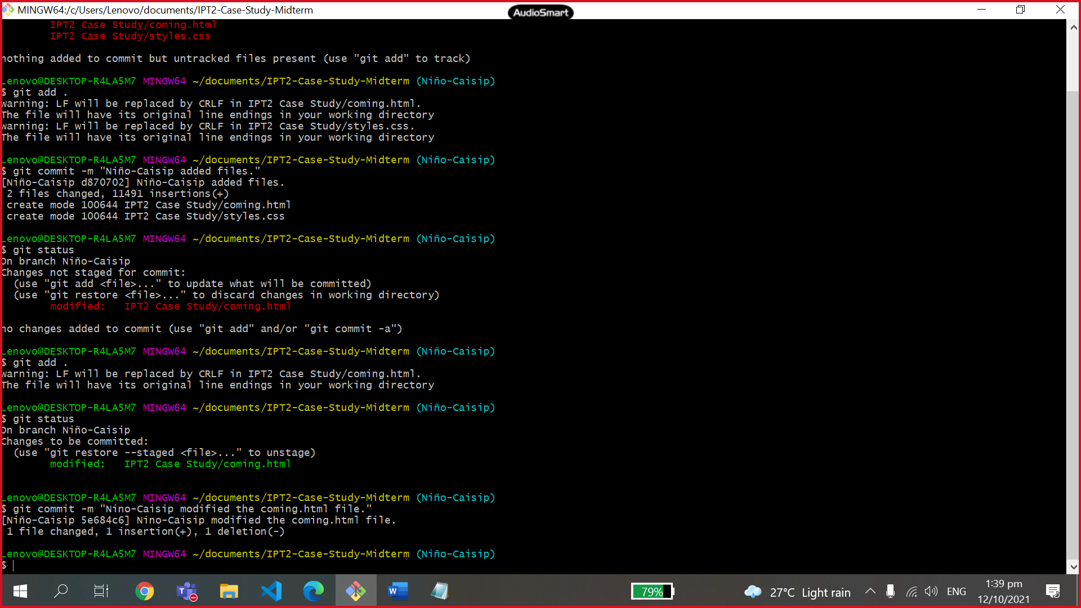

* Check and show all the list of all the commits made to a repository by using git log command.

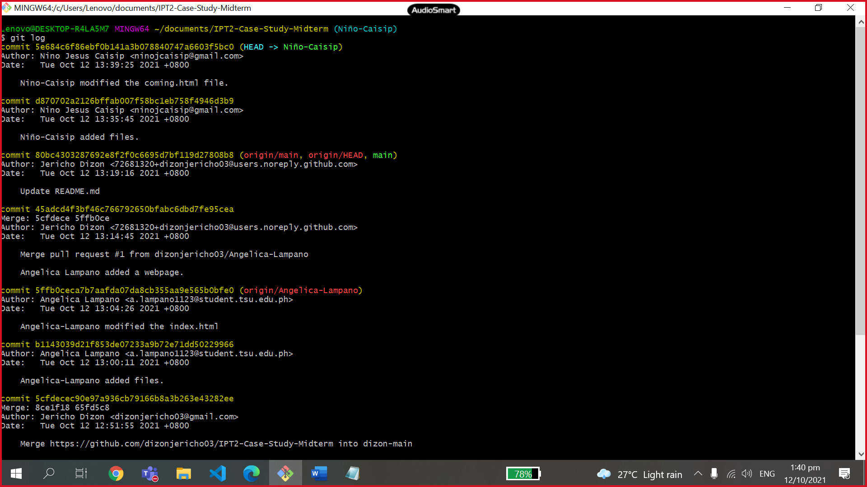

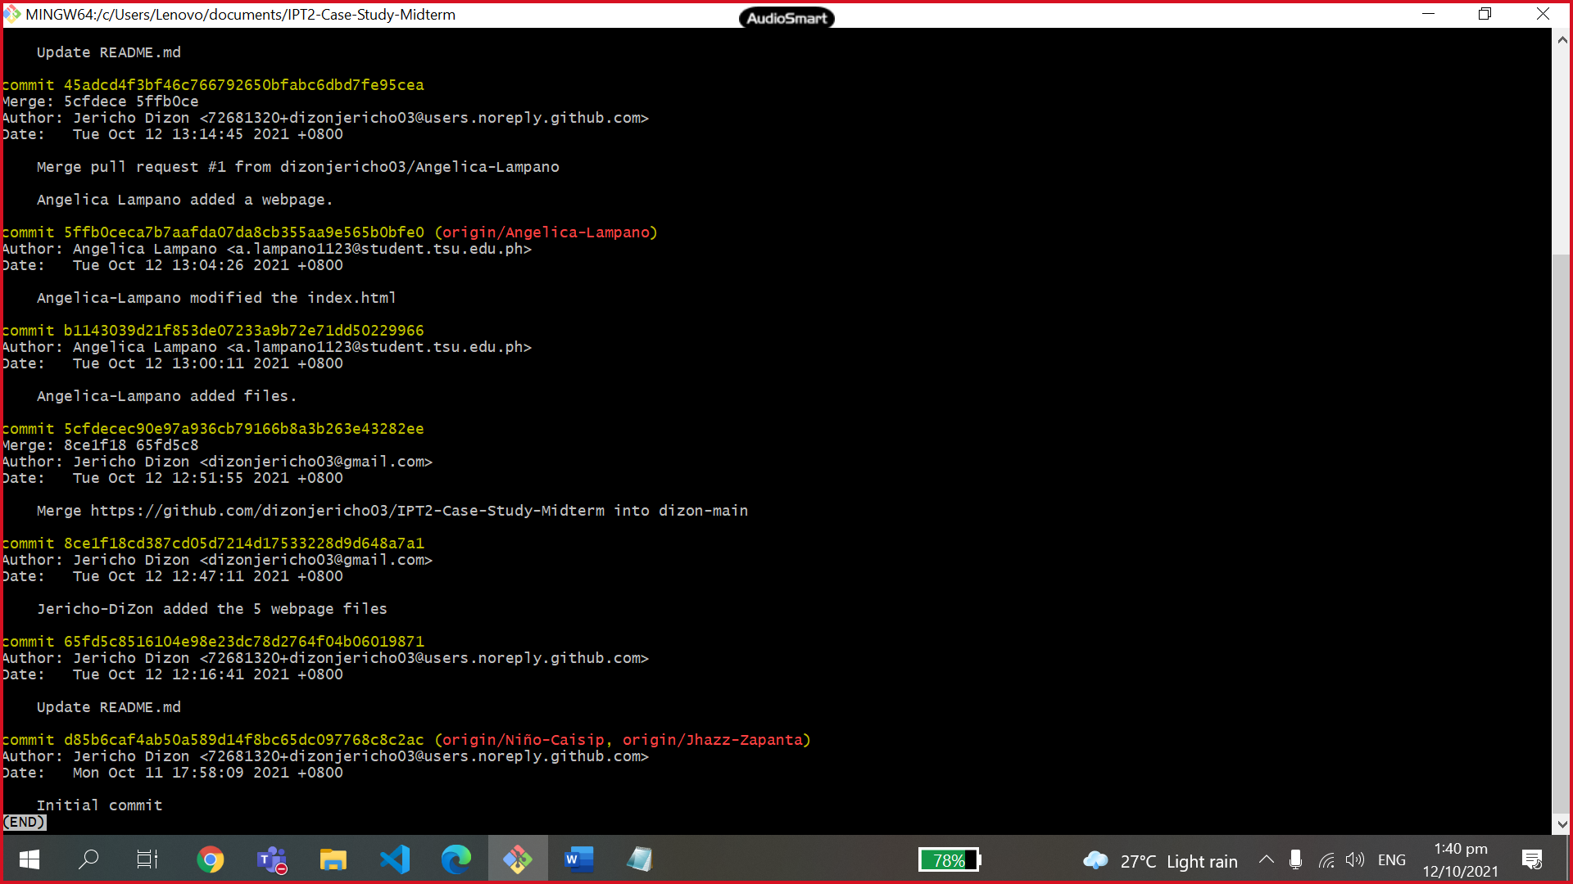

* Check out the branch you want to use.
* Merged the main branch with another branch using the git merge --no-ff Nino-Caisip -m “message” command.

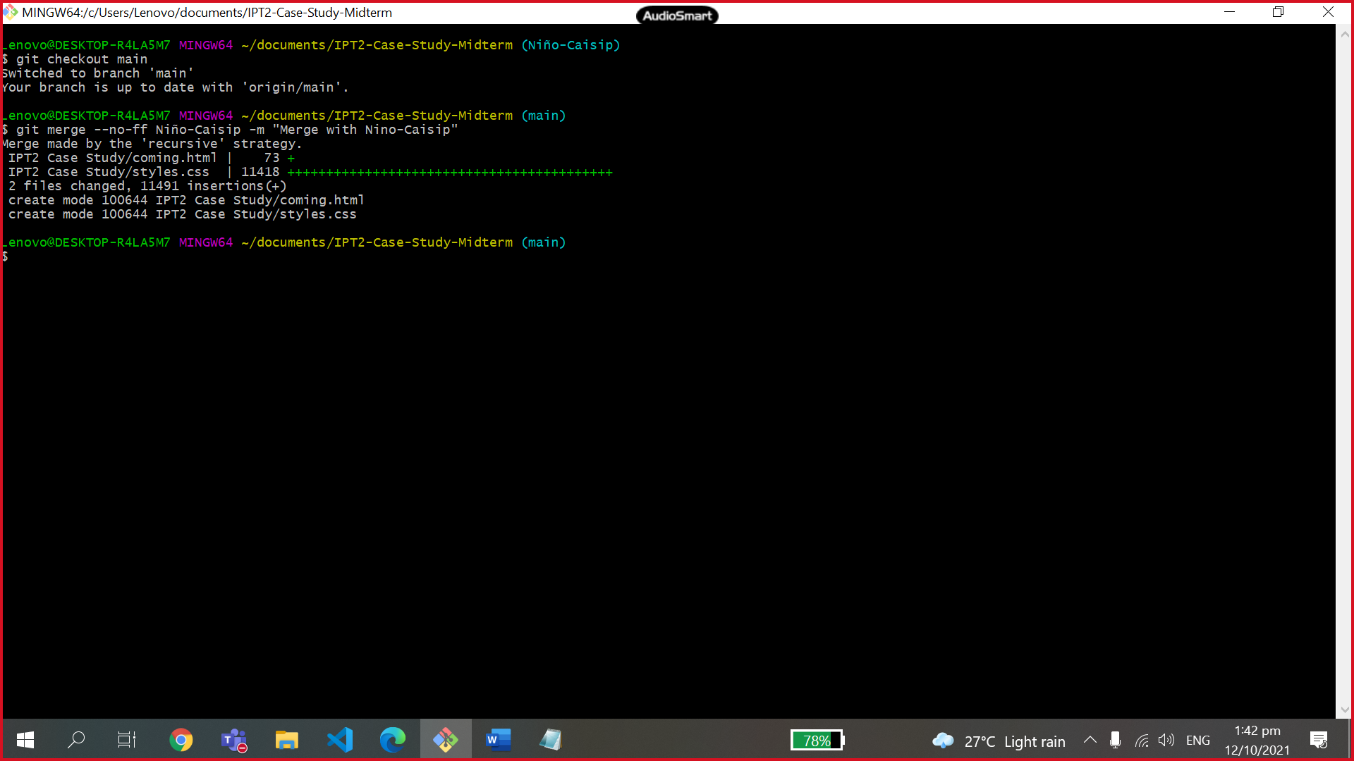

* Check and show all the list of all the commits made to a repository by using git log command.

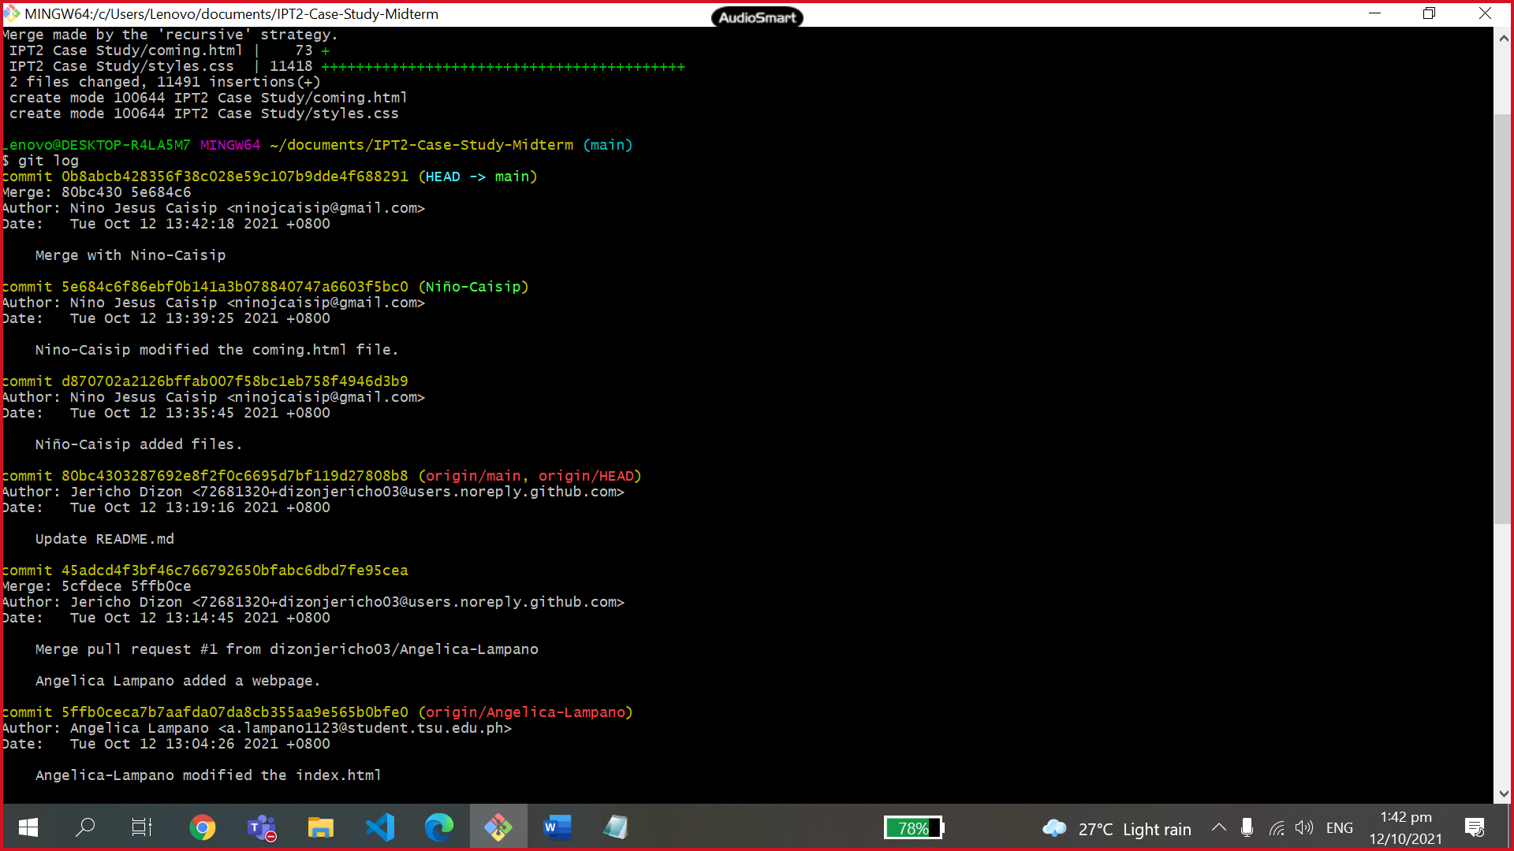

* Check out to your own branch.
* Push all the added files from own local repository to the remote repository in GitHub.

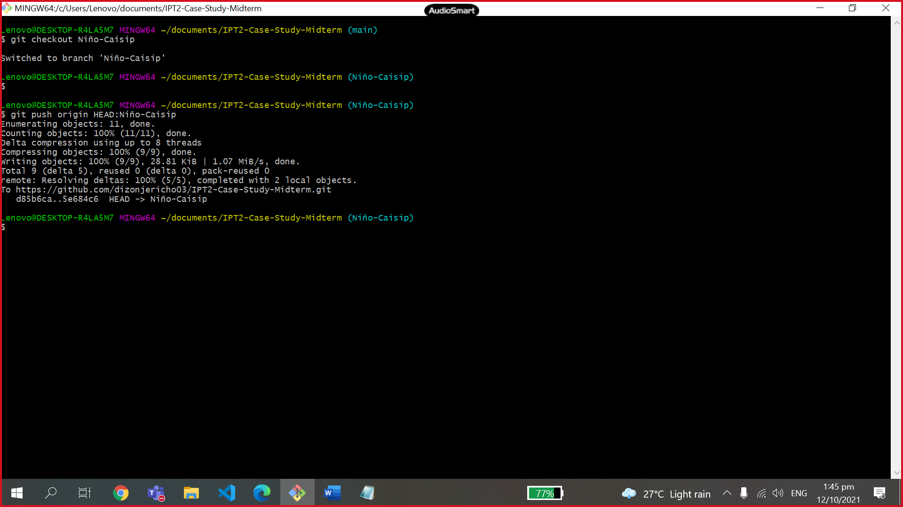

* Navigate to the original GitHub repository, and you should see a big green button marked "Compare and pull request".



* Click that button and you will be taken to a page giving you the opportunity to describe your pull request and showing you the changes, you have made.



* Create an issue from a repository
* Under your repository name, click “ISSUES”
* Click New Issue
* Type a title and description for your issue.
* When you're finished, click **Submit new issue**.



* **Jhazz B. Zapanta (Jhazz-Zapanta)**
* Open the git bash command line.
  + Set and configure your username and user email. (proof of username and user email.)

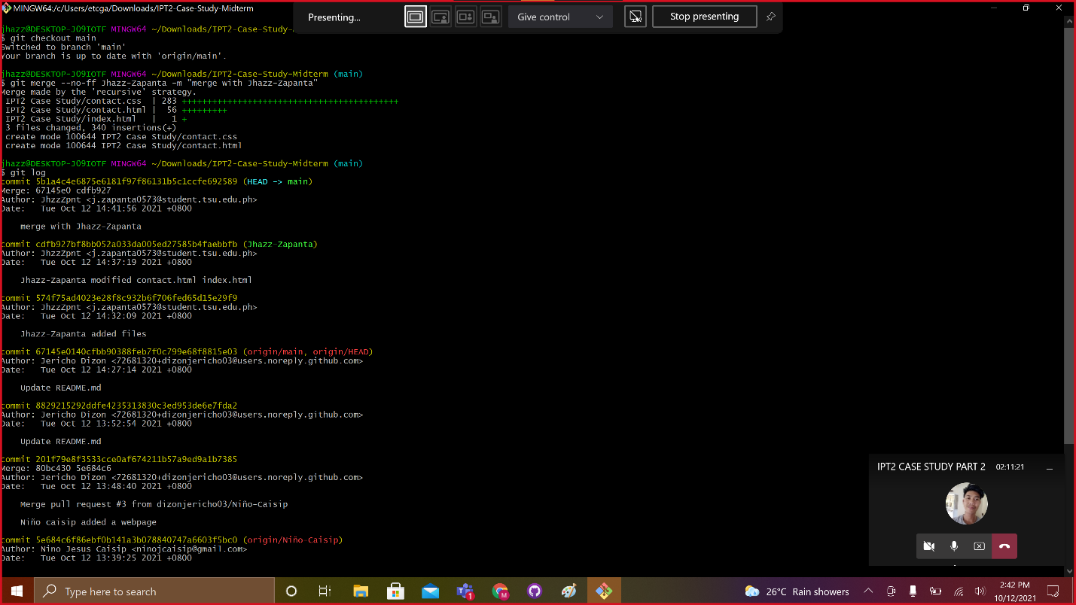

* Go to GitHub and copy the repository link.



* Check the current folder using ls command.
* Type cd Downloads.
* Create a file to a repository.

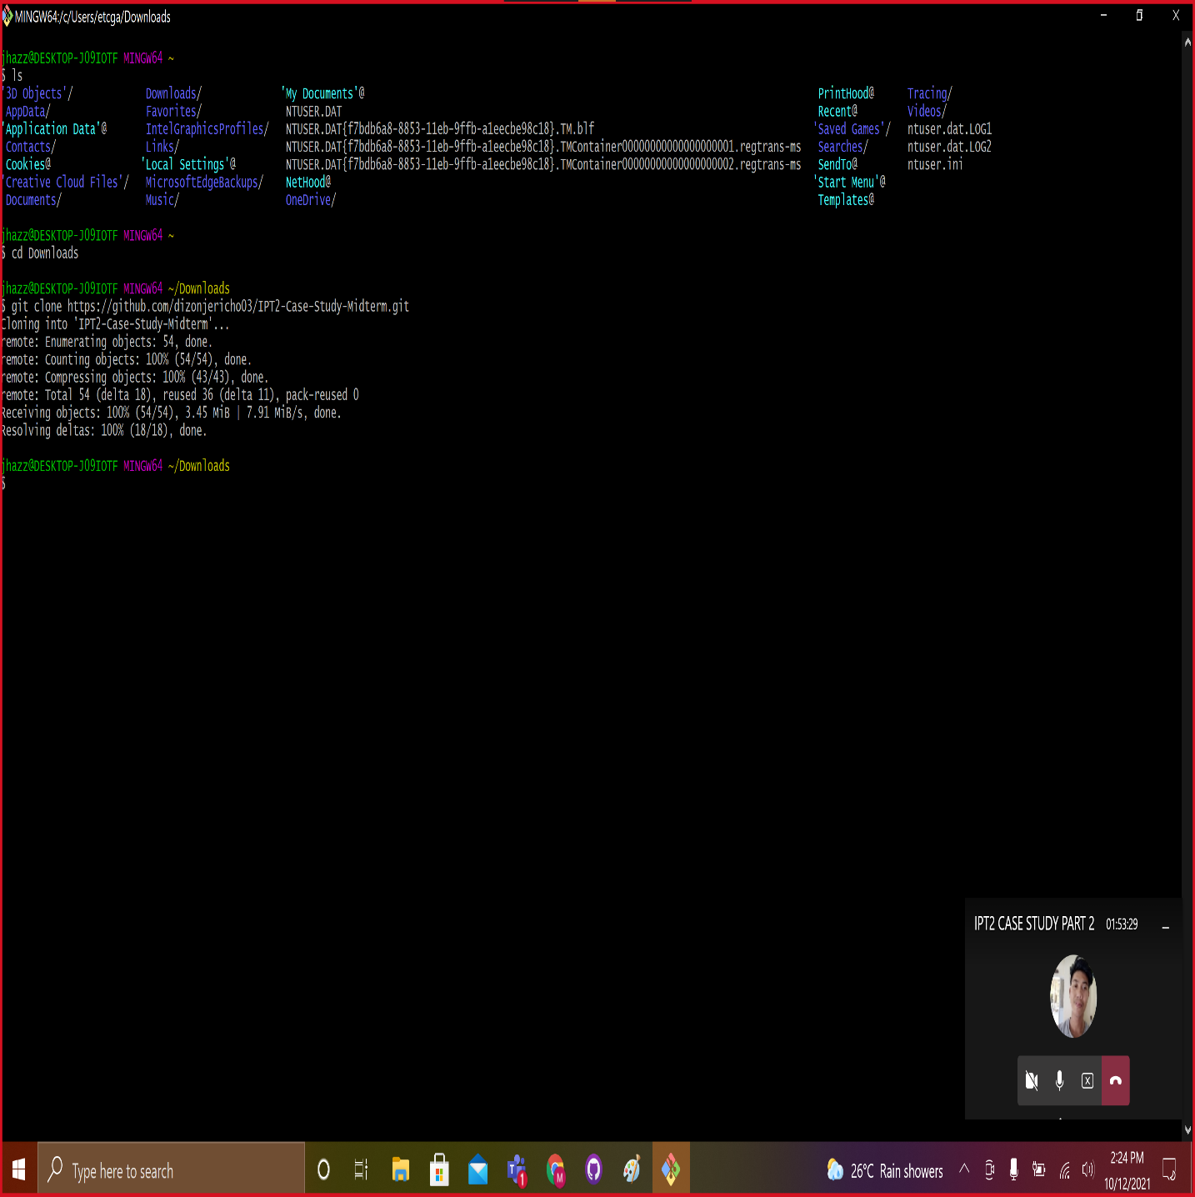

* Fetch and pull the remote repository.
* Add file to repository
* Commit and create a message or comment.
* Check the status of your branch

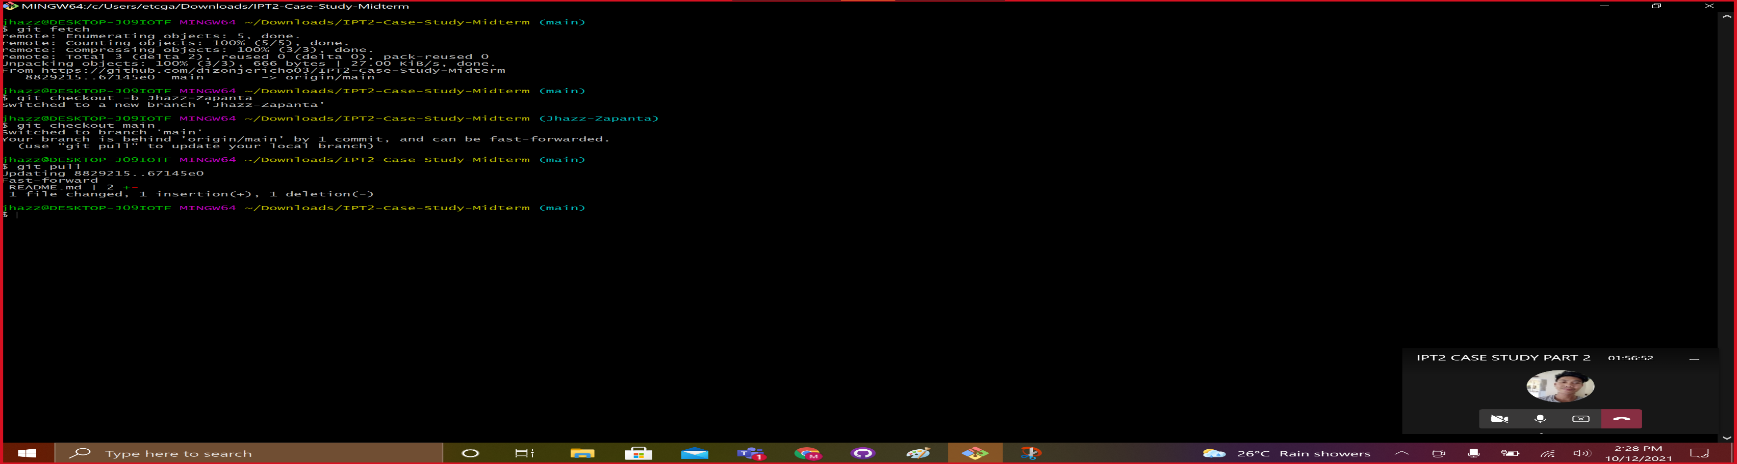

* Check and show all the list of all the commits made to a repository by using git log

command.

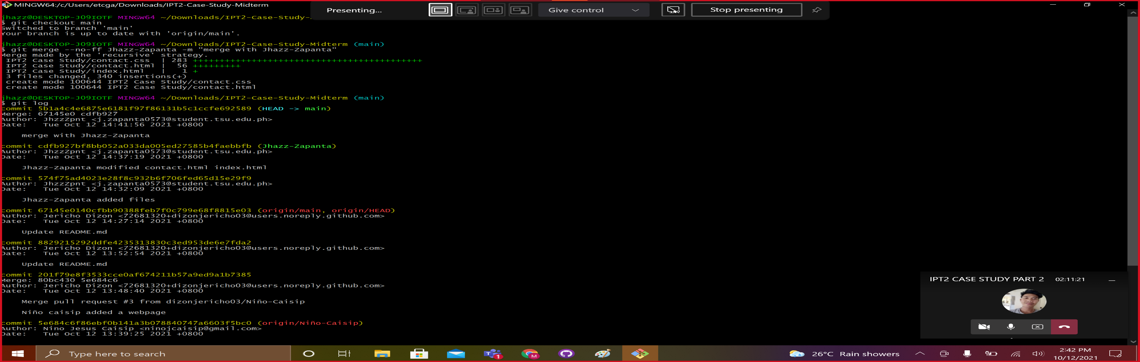

* Check out the branch you want to use.
  + Merged the main branch with another branch using the git merge --no-ff Jhazz Zapanta -m “message” command.



* + Check and show all the list of all the commits made to a repository by using git log command.

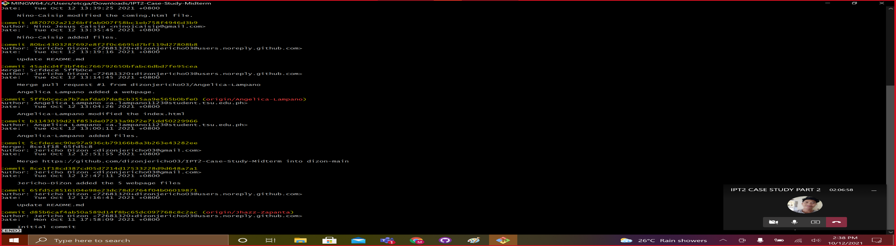

* Check out to your own branch.
  + Push all the added files from own local repository to the remote repository in GitHub.

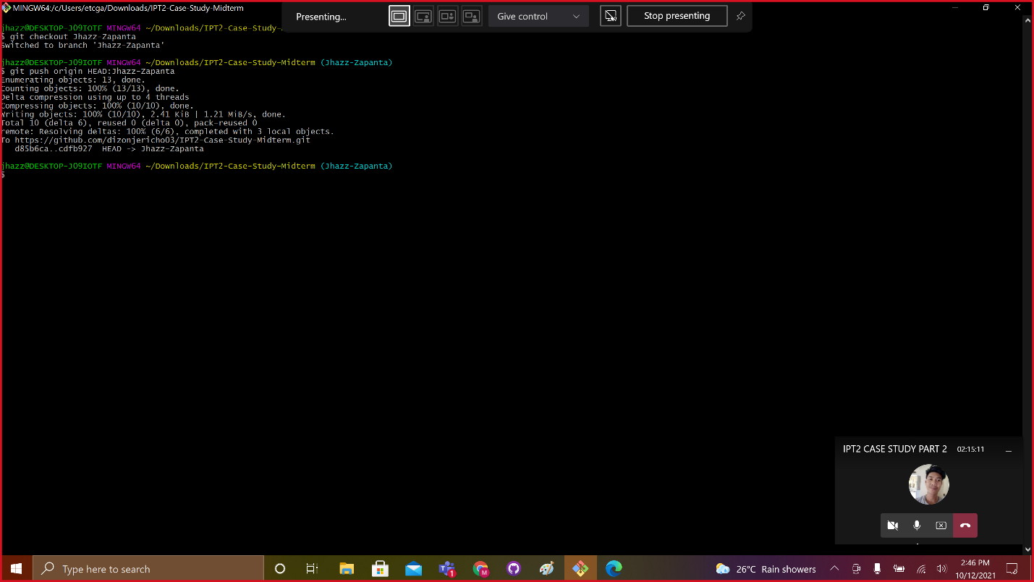

* + Navigate to the original GitHub repository, and you should see a big green button marked "Compare and pull request".

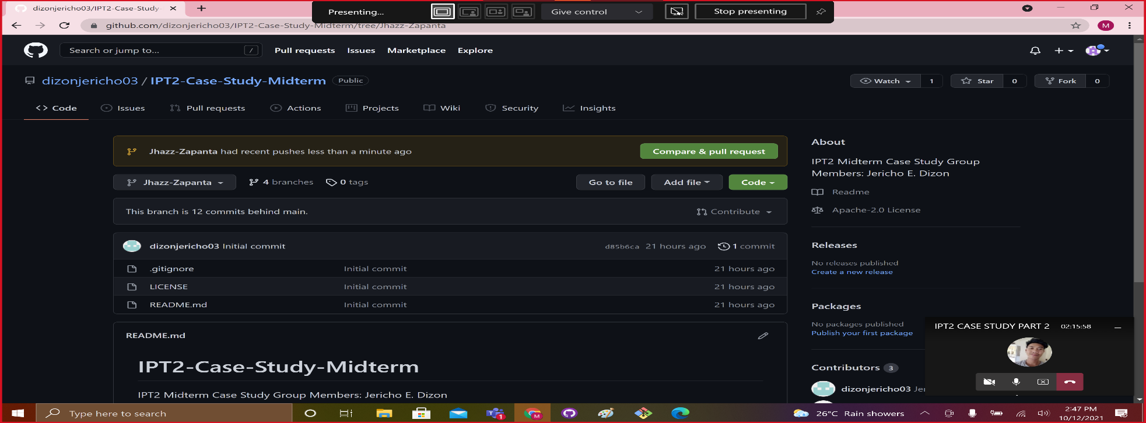

* + Click that button and you will be taken to a page giving you the opportunity to describe your pull request and showing you the changes, you have made.

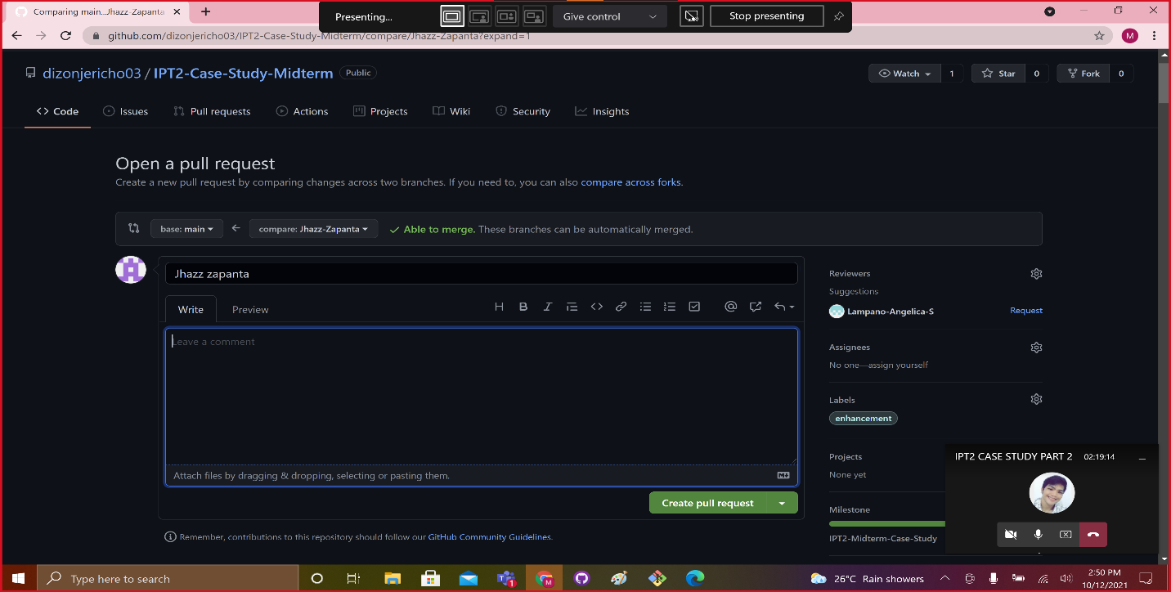

* Create an issue from a repository
* Under your repository name, click “ISSUES”
* Click New Issue
* Type a title and description for your issue.
* When you're finished, click **Submit new issue**.

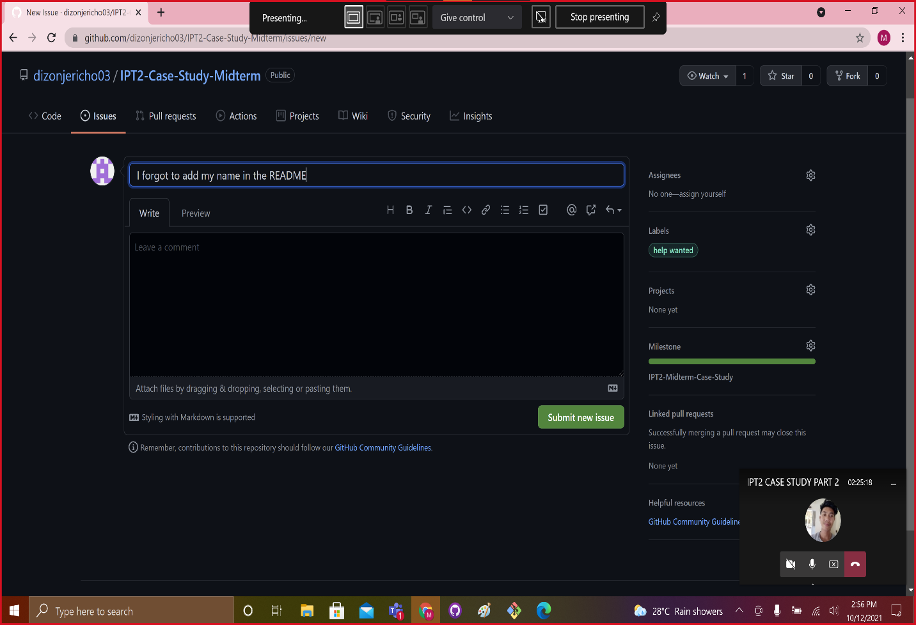

# C. Case Study Webpages

* + **Webpage 1: HOME PAGE**

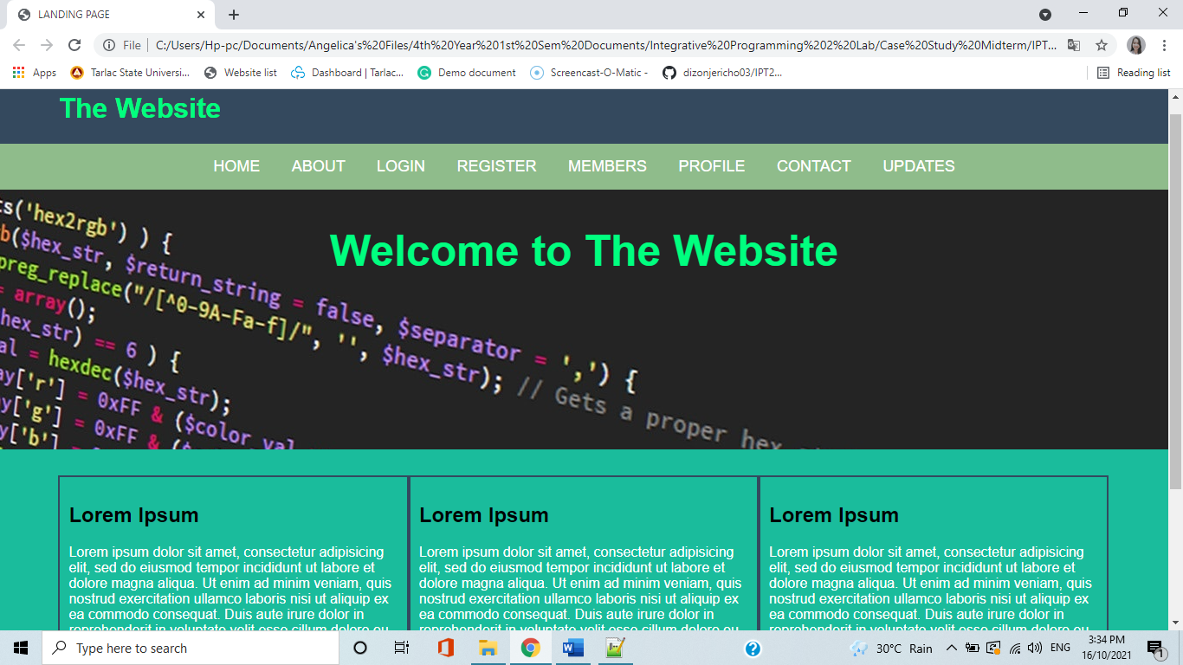

* + **Webpage 2: ABOUT PAGE**

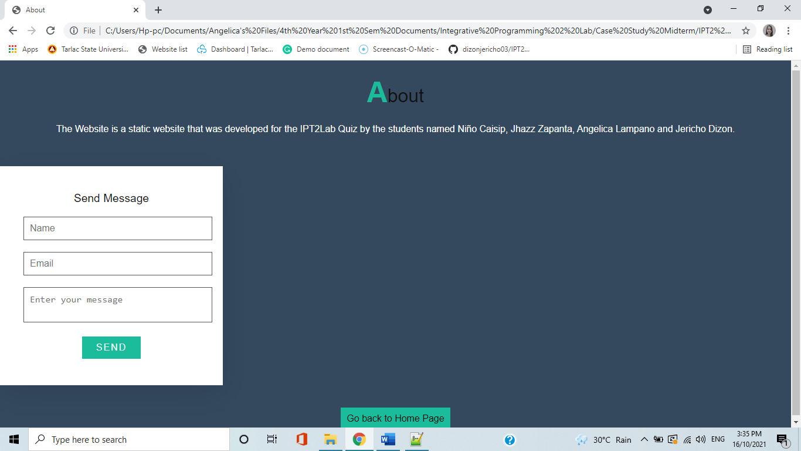

* + **Webpage 3: LOGIN PAGE**

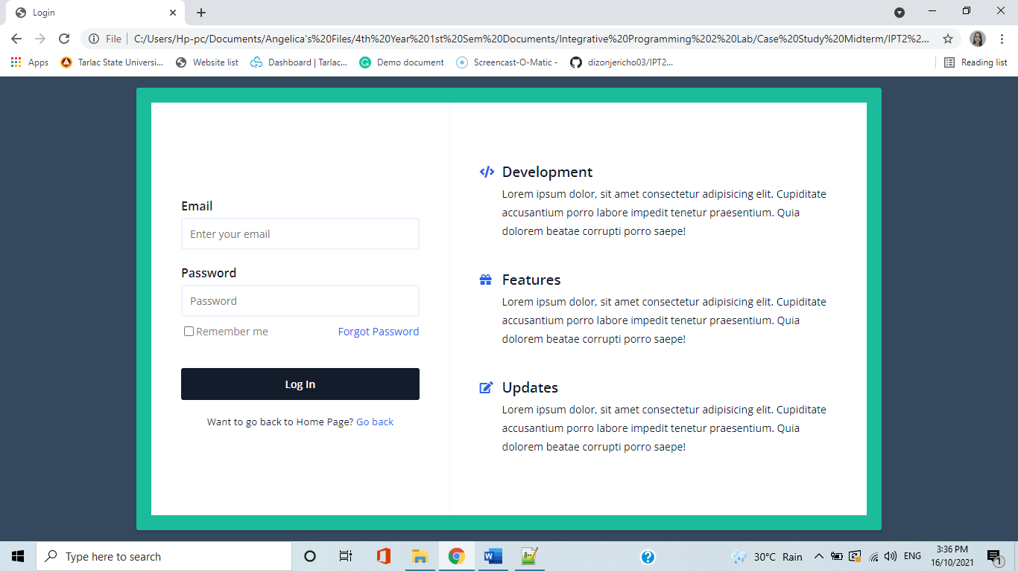

* + **Webpage 4: REGISTRATION PAGE**

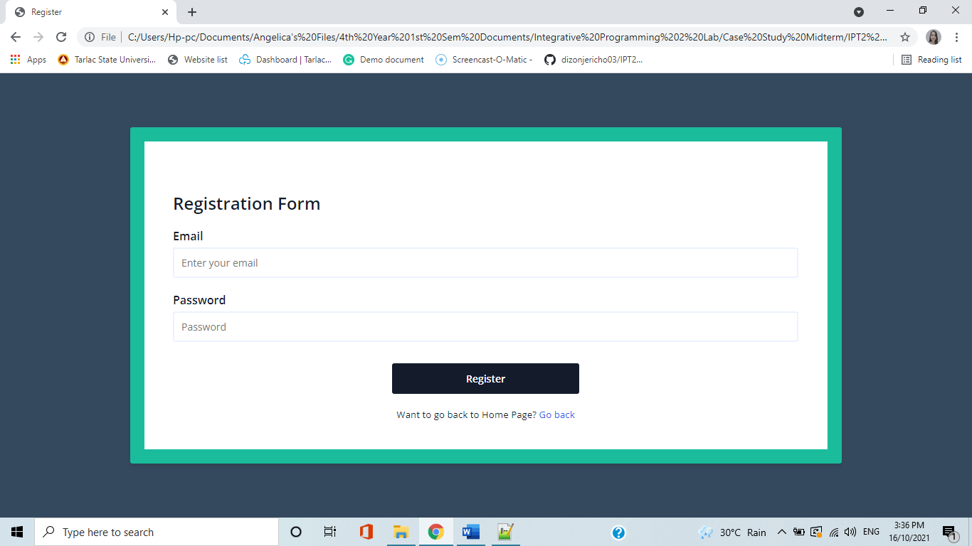

* + **Webpage 5: MEMBERS PAGE**

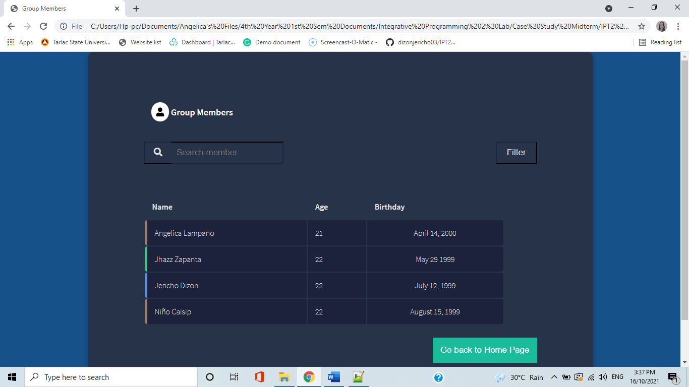

* + **Webpage 6: PROFILE PAGE**



* + **Webpage 7: CONTACT PAGE**

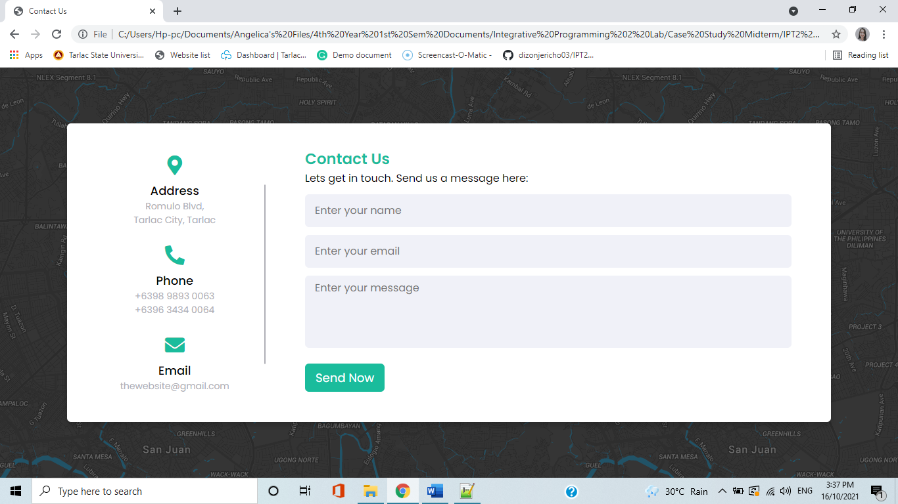

* + **Webpage 8: HOME PAGE**

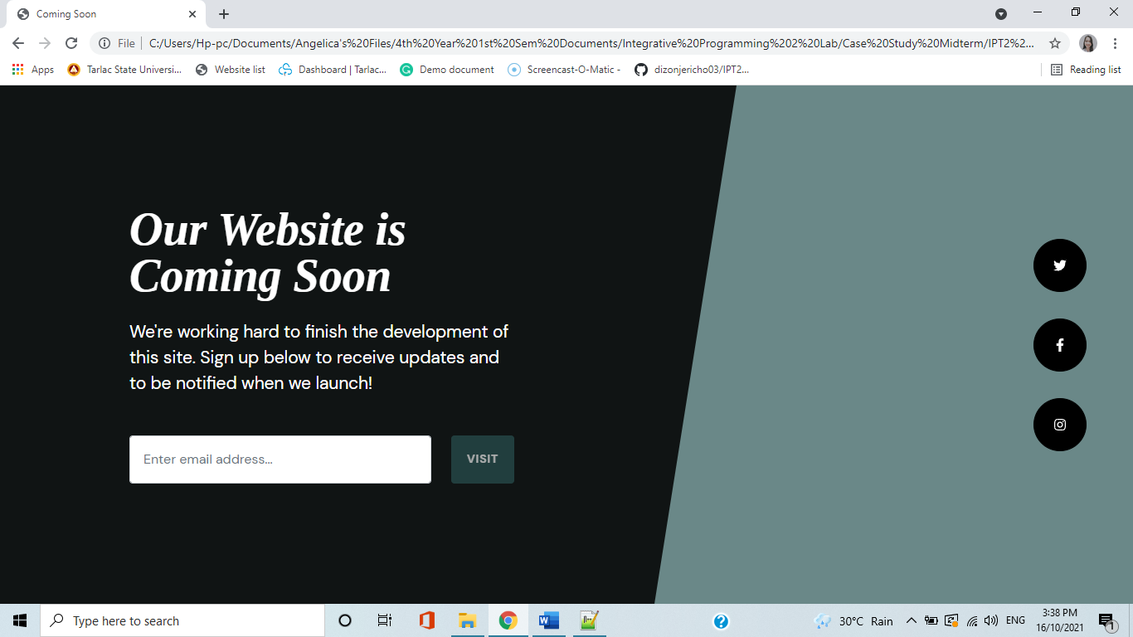

# D. References

# References

|  |  |
| --- | --- |
| [1] | J. Dizon, "IPT2-Case-Study-Midterm," October 2021. [Online]. Available: https://docs.github.com/en/get-started/using-git/getting-changes-from-a-remote-repository. |
| [2] | ATLASSIAN, "Atlassian Git Tutorial," [Online]. Available: https://www.atlassian.com/git/tutorials/setting-up-a-repository/git-clone#:~:text=git%20clone%20is%20a%20Git,copy%20of%20the%20target%20repository.&text=Cloning%20a%20local%20or%20remote,options%20to%20partially%20clone%20repositories. [Accessed 12 October 2021]. |
| [3] | ATLASSIAN, "Atlassian Git Tutorial," [Online]. Available: https://www.atlassian.com/git/tutorials/syncing/git-pull. [Accessed 12 October 2021]. |
| [4] | ATLASSIAN, "Atlassian Git Tutorial," [Online]. Available: https://www.atlassian.com/git/tutorials/syncing/git-push#:~:text=The%20git%20push%20command%20is,exports%20commits%20to%20remote%20branches.. [Accessed 12 October 2021]. |
| [5] | ATLASSIAN, "Atlassian Git Tutorial," [Online]. Available: https://www.atlassian.com/git/tutorials/syncing/git-fetch. [Accessed 12 October 2021]. |
| [6] | ATLASSIAN, "Atlassian Git Tutorial," [Online]. Available: https://www.atlassian.com/git/tutorials/using-branches/git-merge#:~:text=Git%20merging%20combines%20sequences%20of,conflict%20in%20both%20commit%20sequences.. [Accessed 12 October 2021]. |
| [7] | G. Inc., "GitHub Docs," [Online]. Available: https://docs.github.com/en/issues/tracking-your-work-with-issues/about-issues. [Accessed 12 October 2021]. |
| [8] | ATLASSIAN, "Atlassian Git Tutorial," [Online]. Available: https://docs.github.com/en/issues/tracking-your-work-with-issues/about-issues. [Accessed 12 October 2021]. |
| [9] | G. Inc., "GitHub Docs," [Online]. Available: https://docs.gitlab.com/ee/user/project/milestones/. [Accessed 12 October 2021]. |
| [10] | ATLASSIAN, "Atlassian Git Tutorial," [Online]. Available: https://www.atlassian.com/git/tutorials/using-branches. [Accessed 12 October 2021]. |

**Grade Matrix:**

Git Command : **20%**

GitHub Implement : **20%**

Documentation : **40%**

Webpage (Development) : **30%**

**100%**